**UNIVERSITY OF BUEA**  **REPUBLIC OF CAMEROON**

P.O. Box 63, PEACE-WORK-FATHERLAND

Buea, South west region

CAMEROON

Tel: (237) 670731794

FACULTY OF ENGINEERING AND TECHNOLOGY

DEPARTMENT OF COMPUTER ENGINEERING

**DESIGN AN IMPLEMENTATION OF AN ONLINE HYPERMAKET**

**(CAMERCORNER)**

*A dissertation submitted to the department of Computer engineering,*

*Faculty of Engineering and Technology, University of Buea, in Partial*

*Fulfilment of the Requirements for the Award of the Bachelor of Engineering*

*(B.Eng.) Degree in Computer Engineering*

**By**

**DJOUKENG NOUGNING YANNICK IVAN**

**Matriculation Number: FE20A030**

**Option: Software Engineering**

Academic supervisor

Dr. TSAGUE ALINE/Mrs Zile Virginie

University of Buea

Academic Year: 2023/2024

**Table of Contents**

ACKNOWLEDGMENT iii

ABSTRACT v

CHAPTER ONE: GENERAL INTRODUCTION 1

1.1 BACKGROUND AND CONTEXT OF THE STUDY 1

1.2 PROBLEM STATEMENT 1

1.3 OBJECTIVES OF THE STUDY 2

1.4 SIGNIFICANCE OF THE STUDY 3

1.5 SCOPE OF THE PROJECT 4

1.6 DELIMITAIONS OF THE PROJECT 6

CHAPTER TWO: LITERATURE REVIEW 8

2.1 INTRODUCTION 8

2.2 GENERAL CONCEPTS OF THIS TOPIC 8

2.3 OVERVIEW OF E-COMMERCE GIANTS 9

2.4 COMPARATIVE ANALYSIS 11

2.4 IMPLICATIONS FOR THE COMING SYSTEM 13

2.4 PARTIAL CONCLUSION 13

CHAPTER THREE: ANALYSIS AND DESIGN 14

CHAPTER FOUR: IMPLEMENTATION AND RESULTS 30

CHAPTER FIVE: CONCLUSIONS AND FUTHER WORKS 42

5.1 SUMMARY OF THE WORK 42

5.2 CONTRIBUTIONS TO ENGINEERING AND TECHNOLOGY 43

5.3 RECOMMENDATIONS 44

5.4 DIFFICULTIES ENCOUNTERED 46

5.4 FUTHER WORKS 47

REFERENCES 48

**CERTIFICATION OF ORIGINALITY**

We the undersigned, hereby certify that this dissertation entitled “**DESIGN AN IMPLEMENTATION OF AN ONNLINE HYPERMARKET**” presented by DJOUKENG NOUGNING YANNICK IVAN**, Matriculation number FE20A030** has been carried out by him in the Department of Computer Engineering, Faculty of Engineering and Technology, University of Buea under the supervision of **Dr. TSAGUE ALINE and Mrs. Zile Virginie**

This dissertation is authentic and represents the fruits of his/her own research and efforts.

**Student**  **Supervisor**

________________________

____________________________

**Head of Department**

____________________________

# ACKNOWLEDGMENT

I thank God Almighty for a successful training period at the Faculty of Engineering and Technology of the University of Buea

The Dean Emeritus of the Faculty of Engineering and Technology, Prof. TANYI EMMANUEL who gave me the privilege of studying in this incredible faculty.

The Dean of the Faculty of Engineering and Technology, Dr. Agbor Dieudonne Agbor, under whose supervision my training in this incredible school.

My academic supervisor Dr. TSAGUE Aline, for guidance in the writing of this report in the best of maternal ways.

My Parents Mr. DJOUKENG Jean Robert and Mrs. DJOUKENG Madeleine for their continuous love, moral and financial support, prayers and encouragement throughout my academics.

My course mates and fellow cartel members for the academic support and encouragement.

# ABSTRACT

The rapid advancement of technology and the internet has revolutionized the way businesses operate, paving the way for the development of online marketplaces. This project report details the design and implementation of an online hypermarket, aimed at providing a comprehensive and user-friendly platform for consumers to purchase a wide range of products from the comfort of their homes. A unique feature of this project is that the sellers on the platform are exclusively students, offering them a valuable opportunity to engage in entrepreneurship and generate income.

The primary objective of this project is to create an efficient, scalable, and secure e-commerce website that offers a seamless shopping experience while empowering student sellers. The project encompasses the complete development lifecycle, including requirement analysis, system design, implementation, and testing. Key features of the online hypermarket include a robust product catalog, advanced search functionality, secure payment processing, user account management, and an intuitive user interface.

Throughout the development process, industry best practices and modern web technologies were employed to ensure high performance and reliability. The report also highlights the challenges encountered during the project and the strategies employed to overcome them.

The successful implementation of the online hypermarket demonstrates the potential for digital transformation in the retail sector and provides a foundation for future enhancements and scalability. By focusing on student sellers, this project not only contributes to the field of e-commerce but also supports the entrepreneurial ambitions of the student community, offering them a platform to showcase and sell their products.

**Table of Figures**

Figure 1: Agile Methodology 19

Figure 2 : System Architecture 21

Figure 3: Summary Use Case Diagram of the System 23

Figure 4: Summarized Class Diagram of CamerCorner 24

Figure 5: Login Sequence Diagram 25

Figure 6: Registration Sequence Diagram 25

Figure 7: Product Upload Sequence Diagram 26

Figure 8: Buy Sequence Diagram 26

Figure 9: Customer Purchasing good activity diagram 27

Figure 10: Landing page 35

Figure 11: Shop Page 35

Figure 12:Shop Detail Page 36

Figure 13: user product cart 37

Figure 14: User Checkout 37

Figure 15: Login Page 38

Figure 16: User Dashboard 39

Figure 17: User products 39

Figure 18: user product details 39

Figure 19: Update profile 40

Figure 20: Admin dashboard 41

Figure 21: Administrator product upload 41

# CHAPTER ONE: GENERAL INTRODUCTION

## 1.1 BACKGROUND AND CONTEXT OF THE STUDY

A hypermarket is a large retail store that combines a supermarket and a department store. It offers a wide range of products, including groceries, clothing, electronics, household goods, and more, all under one roof. This concept originated to provide consumers with the convenience of one-stop shopping, saving them time and effort by meeting all their needs in a single location.

With the advent of the internet and digital technologies, the traditional hypermarket model has evolved into the online hypermarket. An online hypermarket retains the comprehensive product offerings of a physical hypermarket but delivers them through a digital platform. This transformation has revolutionized the shopping experience by allowing consumers to browse and purchase products from the comfort of their homes, at any time of the day.

## 1.2 PROBLEM STATEMENT

Despite the widespread adoption of e-commerce, students in our Buea often face significant barriers when attempting to enter the market as sellers. These barriers include high entry costs, a lack of goods to sell, a lack of technical knowledge, and limited access to established e-commerce platforms. As a result, many students with entrepreneurial aspirations are unable to participate in the online retail space effectively. There is a critical need for an online marketplace that specifically caters to student sellers, providing them with an accessible, low-cost, and supportive environment to launch their entrepreneurial ventures.

## 1.3 OBJECTIVES OF THE STUDY

The primary objectives of this project are:

1. **To design and implement an online hypermarket that caters specifically to student sellers.**
   * Create a platform that allows students to easily register, list products, and manage their online stores.
   * Offer the possibility to students to sell products uploaded on the platform even if they are not the uploaders
   * Offer support and resources tailored to the needs of student entrepreneurs.
2. **To provide a user-friendly and secure platform for consumers to purchase a wide range of products.**
   * Ensure a seamless and intuitive shopping experience for consumers.
   * Implement robust security measures to protect user data and transactions.
3. **To empower students by offering them a low-cost, low-barrier entry into the e-commerce market.**
   * Reduce the financial and technical barriers that typically hinder student participation in e-commerce.
   * Promote student entrepreneurship and innovation.
4. **To ensure high performance, scalability, and reliability of the platform through the use of modern web technologies.**
   * Utilize cutting-edge web development practices to build a scalable and efficient platform.
   * Regularly update and maintain the platform to meet evolving user needs and technological advancements.
5. **To provide flexible product management options for student sellers.**
   * Allow student sellers to either sell products that have been pre-uploaded by the platform administrator or upload their own unique products.
   * Ensure that both options are easy to use and well-integrated into the platform’s overall system.

## 1.4 SIGNIFICANCE OF THE STUDY

The significance of the "Design and Implementation of an Online Hypermarket" project to the community can be substantial, particularly given its focus on student sellers. Here are some key points highlighting its importance:

**1. Empowerment of Student Entrepreneurs**

* **Economic Opportunities:** By providing a platform specifically for student sellers, the project creates new economic opportunities for young entrepreneurs. Students can generate income and gain practical business experience.
* **Skill Development:** The platform encourages students to develop essential skills such as marketing, financial management, customer service, and technological proficiency.
* **Reduced Barriers:** The project lowers entry barriers to the e-commerce market, making it easier for students to start and manage their businesses without significant financial investment or advanced technical knowledge.

**2. Enhanced Consumer Access**

* **Convenience:** Consumers in the community benefit from the convenience of shopping online, accessing a wide range of products from the comfort of their homes.
* **Diverse Product Offerings:** The platform offers a variety of products, including those uniquely crafted by students, which may not be available in traditional retail stores.
* **Supporting Local Talent:** By purchasing from student sellers, consumers directly support local talent and contribute to the community's economic growth.

**3. Community Building**

* **Network Creation:** The platform fosters a sense of community by connecting student sellers with consumers and other entrepreneurs, creating a network of support and collaboration.
* **Local Economy Boost:** Keeping economic activities within the community helps boost the local economy, creating a positive feedback loop of growth and development.
* **Innovation Hub:** The project can become a hub for innovation, encouraging more students to explore entrepreneurial ventures and contribute new ideas and products to the market.

**4. Educational Impact**

* **Practical Learning:** Students gain hands-on experience in running a business, complementing their academic education with practical knowledge and skills.
* **Entrepreneurial Mindset:** The platform promotes an entrepreneurial mindset among students, encouraging them to think creatively and take initiative in solving problems and meeting market demands.
* **Mentorship Opportunities:** Experienced entrepreneurs and community leaders can provide mentorship and guidance to student sellers, further enriching their learning experience.

**5. Technological Advancement**

* **Digital Literacy:** By engaging with the platform, both sellers and consumers enhance their digital literacy, becoming more comfortable with using technology for business and everyday transactions.
* **Innovation in Retail:** The project introduces modern web technologies and e-commerce practices to the community, setting a benchmark for future digital initiatives and encouraging further technological adoption.

In summary, the "Design and Implementation of an Online Hypermarket" project has the potential to significantly benefit the community by empowering student entrepreneurs, enhancing consumer access to diverse products, fostering community building, providing educational opportunities, and advancing technological adoption. It creates a vibrant ecosystem where students can thrive as business owners, consumers can enjoy convenient shopping experiences, and the community as a whole can experience economic and social growth.

## 1.5 SCOPE OF THE PROJECT

This project will encompass the following aspects:

1. **Requirement Analysis**
   * Identify the specific needs and preferences of student sellers and consumers through surveys, interviews, and market research.
2. **System Design**
   * Develop a comprehensive architectural plan for the online hypermarket, including database design, user interface design, and system architecture.
3. **Implementation**
   * Build the platform using appropriate web technologies such as HTML, CSS, JavaScript, and backend frameworks.
   * Integrate essential features such as product catalog management, advanced search functionality, secure payment processing, and user account management.
   * Implement functionality for students to choose from administrator-uploaded products or upload their own products.
4. **Testing**
   * Conduct thorough testing to ensure the platform meets the required standards of functionality, performance, and security.
   * Address any issues or bugs identified during the testing phase to ensure a smooth user experience.
5. **Deployment and Maintenance**
   * Deploy the platform to a live server and monitor its performance.
   * Provide ongoing maintenance and support to ensure the platform remains reliable and up-to-date.
6. **Financial Expectations**

* Estimate the initial setup and development costs, including web hosting, domain registration, and development tools.
* Project the operating expenses, such as server maintenance, customer support, and marketing.
* Analyze potential revenue streams, including transaction fees, subscription models for premium seller accounts, and advertising.
* Develop a financial model to predict the platform's profitability over a specified period, considering different growth scenarios and user acquisition rates.

This project aims to bridge the gap between student entrepreneurs and the e-commerce market, offering a unique platform that supports and nurtures their business ambitions while providing consumers with a diverse and convenient shopping experience.

## 1.6 DELIMITAIONS OF THE PROJECT

1. **Target Audience**
   * The platform is specifically designed for student sellers and consumers. Sellers who are not students will be allowed to use the platform but at a higher cost.
2. **Product Categories**
   * The online hypermarket will initially focus on a limited range of product categories such as clothing, electronics, books, and handmade crafts. Expansion into other categories like groceries, household items, and services will be considered in future phases.
3. **Geographical Scope**
   * The platform will be launched and tested in its town of birth, i.e. Buea. Expansion to other regions or countries will be considered based on the success and scalability of the initial launch.
4. **Technical Features**
   * The initial version of the platform will include basic e-commerce functionalities such as user registration, product listing, search and filter options, shopping cart, checkout, and payment processing. Advanced features like AI-based product recommendations, real-time customer support chatbots, and detailed analytics dashboards will be considered for future updates.
5. **Payment Methods**
   * The platform will support commonly used online payment methods such as MTN Mobile Money and Orange Money. Integration with other payment methods like cryptocurrency or region-specific digital wallets will be evaluated in later stages.
6. **Language Support**
   * The platform will be developed in English initially. Multilingual support will be considered for future versions based on user demand and geographic expansion.
7. **Marketing and Promotion**
   * Marketing efforts will primarily focus on digital channels such as social media, search engine optimization (SEO), and email marketing. Traditional marketing methods like print advertising or TV commercials are not included in the initial marketing strategy.
8. **User Support**
   * The platform will offer basic customer support through email and a help center with FAQs and guides. Live chat support and phone support may be added in future iterations based on user feedback and demand.
9. **Data Storage and Privacy**
   * User data will be stored and managed in compliance with local data protection regulations. The project will not include comprehensive international data compliance measures initially, but these will be considered as the platform expands globally.
10. **Customizability**

* While the platform will offer some degree of customization for user storefronts (e.g., themes, logos, and product descriptions), it will not support extensive customization options like bespoke feature development or complex integrations with external systems in the initial version.

## CHAPTER TWO: LITERATURE REVIEW

## 2.1 INTRODUCTION

The online hypermarket concept has been significantly influenced by the evolution of e-commerce giants like Amazon, Alibaba, and local platforms such as Buyam. This literature review examines the development, features, and impact of these established systems to provide a comprehensive understanding of the landscape in which the proposed online hypermarket for student sellers will operate. Additionally, it explores general concepts relevant to e-commerce and online hypermarkets.

## 2.2 GENERAL CONCEPTS OF THIS TOPIC

1. **E-commerce:** E-commerce, or electronic commerce, refers to the buying and selling of goods and services over the internet. This concept has revolutionized traditional retail by providing a convenient and accessible platform for consumers and sellers. Key elements of e-commerce include:

* **Digital Transactions:** E-commerce platforms facilitate digital transactions, reducing the need for physical currency and enabling secure, cashless payments.
* **Global Reach:** The internet allows businesses to reach a global audience, breaking down geographical barriers.
* **24/7 Availability:** E-commerce stores operate around the clock, providing consumers with the flexibility to shop at any time.
* **Data Analytics:** E-commerce platforms leverage data analytics to understand consumer behavior, optimize inventory management, and personalize the shopping experience.

1. **Online Hypermarket**: An online hypermarket is a large-scale e-commerce platform that offers a wide range of products across various categories, similar to a physical hypermarket but in a digital format. Key characteristics include:

* **Extensive Product Range:** Online hypermarkets provide consumers with a vast selection of products, from groceries and electronics to clothing and household items.
* **Convenience:** Consumers can browse, compare, and purchase products from the comfort of their homes, without the need to visit multiple physical stores.
* **Competitive Pricing:** The online nature of these platforms often results in competitive pricing due to reduced overhead costs and the ability to source products from multiple suppliers.
* **Integrated Services:** Online hypermarkets may offer additional services such as home delivery, subscription options, and personalized recommendations to enhance the shopping experience.

1. **Marketplace Model:** Many online hypermarkets operate on a marketplace model, where the platform acts as an intermediary between buyers and sellers. Key aspects of this model include:

* **Third-Party Sellers:** Independent sellers can list their products on the platform, expanding the product range and offering more choices to consumers.
* **Commission-Based Revenue:** The platform typically earns revenue through commissions on sales made by third-party sellers.
* **Seller Support:** Marketplaces provide tools and resources to help sellers manage their listings, process orders, and handle customer service.

## 2.3 OVERVIEW OF E-COMMERCE GIANTS

**AMAZON**

Amazon, founded by Jeff Bezos in 1994, is one of the largest and most influential e-commerce platforms globally. Initially started as an online bookstore, Amazon has expanded to offer a vast array of products, including electronics, clothing, groceries, and more. Key features of Amazon include:

* **Extensive Product Catalog:** Amazon's diverse product offerings attract a wide range of consumers.
* **User-Friendly Interface:** The platform's intuitive design facilitates easy navigation and product discovery.
* **Advanced Search and Recommendation Systems:** Amazon uses sophisticated algorithms to provide personalized recommendations and search results.
* **Prime Membership:** Offering benefits like free shipping, exclusive deals, and streaming services, Prime membership has significantly boosted customer loyalty.
* **Global Reach:** Amazon operates in numerous countries, providing localized services to cater to different markets.
* **Third-Party Marketplace:** Amazon allows third-party sellers to list products on its platform, expanding its product range and offering more choices to consumers.

**ALIBABA**

Alibaba, founded by Jack Ma in 1999, is a Chinese e-commerce giant that operates primarily in the B2B sector but also includes B2C and C2C platforms. Key components of Alibaba's ecosystem include:

* **Alibaba.com:** A B2B marketplace connecting manufacturers and wholesalers with buyers worldwide.
* **Taobao:** A C2C platform similar to eBay, where individuals can sell products directly to consumers.
* **Tmall:** A B2C platform hosting branded stores for companies to sell products directly to consumers.
* **Alipay:** A secure online payment system integrated into Alibaba's platforms, ensuring seamless transactions.
* **Logistics Network:** Alibaba has developed an extensive logistics network to handle the high volume of goods sold through its platforms.

**BUYAM**

Buyam is a local e-commerce platform designed to cater to specific regional markets. It offers a range of products from local sellers, emphasizing support for small businesses and local entrepreneurs. Key features include:

* **Localized Product Listings:** Buyam focuses on products relevant to the local market, providing a unique shopping experience.
* **Support for Local Sellers:** The platform provides tools and resources to help local businesses and entrepreneurs succeed.
* **Simple User Interface:** Buyam offers a straightforward and easy-to-use interface, making it accessible to a wide range of users.
* **Secure Payment Methods:** The platform ensures secure transactions through trusted payment gateways.

## 2.4 COMPARATIVE ANALYSIS

The proposed online hypermarket for student sellers aims to draw on the strengths and address the limitations of existing platforms like Amazon, Alibaba, and Buyam. A comparative analysis highlights the following key aspects:

**Product Offering and Target Audience**

* **Amazon and Alibaba:** These platforms cater to a broad audience, offering a wide range of products from various categories.
* **Buyam:** Focuses on local markets and products, supporting small businesses and local entrepreneurs.
* **Proposed Online Hypermarket:** Will target student sellers specifically, providing a unique platform for young entrepreneurs to showcase and sell their products. The product range will initially focus on categories relevant to student interests and capabilities, such as clothing, electronics, books, and handmade crafts.

**Seller Support and Resources**

* **Amazon:** Provides comprehensive support for third-party sellers, including tools for inventory management, advertising, and customer service.
* **Alibaba:** Offers extensive resources for businesses, particularly in the B2B sector, including trade assurance and international shipping solutions.
* **Buyam:** Emphasizes support for local sellers with resources tailored to small businesses.
* **Proposed Online Hypermarket:** Will provide targeted support and resources for student sellers, including tutorials on e-commerce, marketing strategies, and financial management. The platform will also offer mentorship opportunities from experienced entrepreneurs.

**User Experience and Interface**

* **Amazon and Alibaba:** Both platforms offer advanced search functionalities, personalized recommendations, and a user-friendly interface.
* **Buyam:** Provides a simple and accessible interface tailored to local users.
* **Proposed Online Hypermarket:** Will prioritize an intuitive and user-friendly interface, with features such as advanced search and filtering options, personalized recommendations, and easy product upload processes for student sellers.

**Payment and Security**

* **Amazon and Alibaba:** Utilize secure payment gateways and offer multiple payment options to ensure safe transactions.
* **Buyam:** Focuses on secure payment methods relevant to the local market such as Mobile Money.
* **Proposed Online Hypermarket:** Will integrate secure payment processing methods, including credit/debit cards and PayPal, with potential for adding local payment options based on user demand. The platform will adhere to strict data protection regulations to ensure user privacy and security.

**Logistics and Delivery**

* **Amazon:** Has developed a sophisticated logistics network, offering fast and reliable delivery options, including same-day and next-day delivery.
* **Alibaba:** Provides logistics solutions through partnerships with third-party logistics providers, ensuring efficient international and domestic shipping.
* **Buyam:** Focuses on local delivery solutions, often partnering with local courier services.
* **Proposed Online Hypermarket:** Will initially rely on existing logistics providers for delivery, with plans to develop a more integrated logistics solution as the platform grows.

## 2.4 IMPLICATIONS FOR THE COMING SYSTEM

The proposed online hypermarket for student sellers can learn from the successes and challenges of Amazon, Alibaba, and Buyam. Key implications include:

* **Niche Focus:** By targeting student sellers, the platform can carve out a unique niche in the e-commerce market, differentiating itself from broader platforms like Amazon and Alibaba.
* **Supportive Ecosystem:** Providing tailored support and resources for student sellers can enhance their success and foster a vibrant community of young entrepreneurs.
* **User Experience:** Prioritizing a user-friendly interface and secure payment processing will ensure a positive experience for both sellers and consumers.
* **Scalability:** While starting with a specific geographical focus and limited product categories, the platform can scale over time based on user demand and market trends

## 2.4 PARTIAL CONCLUSION

The literature review highlights the potential for the proposed online hypermarket to address the unique needs of student sellers while drawing on the strengths of established platforms like Amazon, Alibaba, and Buyam. By focusing on targeted support, user experience, and secure transactions, the project aims to create a sustainable and impactful platform that empowers student entrepreneurs and enhances the local e-commerce landscape.

## CHAPTER THREE: ANALYSIS AND DESIGN

#### 3.1 SYSTEM ANALYSIS

System analysis involves understanding the functional and non-functional requirements of the proposed online hypermarket for student sellers. It is critical to identify user needs, define system requirements, and establish a clear roadmap for the design and implementation phases.

##### 3.1.1 REQUIREMENTS GATHERING

**Functional Requirements:**

1. **User Registration and Authentication:**
   * Users (students) must be able to register and create an account.
   * The system should authenticate users during login.
   * Password recovery options should be available.
2. **User Roles and Permissions:**
   * **Administrator:** Can manage the platform, upload products, and approve student seller registrations.
   * **Student Seller:** Can upload products, manage their listings, and view their sales.
   * **Consumer:** Can browse products, add items to the cart, and make purchases.
3. **Product Management:**
   * Administrators can upload products that student sellers can choose to sell.
   * Student sellers can upload their own products.
   * Product details should include images, descriptions, prices, and categories.
   * Sellers should be able to edit or delete their listings.
4. **Search and Filter:**
   * Consumers should be able to search for products using keywords.
   * Filters should be available for categories, price ranges, and other attributes.
5. **Shopping Cart and Checkout:**
   * Consumers can add products to a shopping cart.
   * The system should support a seamless checkout process, including payment gateway integration.
   * Order summaries and confirmation emails should be sent to consumers.
6. **Order Management:**
   * Sellers should be able to view and manage orders.
   * Order status tracking for consumers.
7. **Reviews and Ratings:**
   * Consumers can leave reviews and ratings for products they purchase.
   * Sellers can respond to reviews.
8. **Notifications:**
   * Email notifications for account registration, order confirmations, and other critical updates.
   * In-platform notifications for sellers regarding new orders and reviews.

**Non-Functional Requirements:**

1. **Scalability:**
   * The system should handle increasing numbers of users and transactions as the platform grows.
2. **Security:**
   * Secure user authentication and data encryption.
   * Compliance with data protection regulations (e.g., GDPR).
3. **Performance:**
   * Fast load times and responsive user interface.
   * Efficient search and filter functionality.
4. **Usability:**
   * Intuitive and user-friendly interface.
   * Accessible design accommodating various devices and screen sizes.
5. **Maintainability:**
   * Modular architecture for easy updates and maintenance.
   * Clear and comprehensive documentation.

##### 3.1.2 USE CASE ANALYSIS

Use cases describe the interactions between users and the system to achieve specific goals. Key use cases for the online hypermarket include:

1. **User Registration and Login:**
   * Actors: Student Seller, Consumer
   * Description: Users can create an account and log in to the system.
2. **Product Browsing and Search:**
   * Actors: Consumer
   * Description: Consumers can browse and search for products using various filters.
3. **Product Management:**
   * Actors: Administrator, Student Seller
   * Description: Administrators can upload products; student sellers can upload and manage their own products.
4. **Shopping Cart and Checkout:**
   * Actors: Consumer
   * Description: Consumers can add items to their cart and complete purchases through a secure checkout process.
5. **Order Management:**
   * Actors: Student Seller, Consumer
   * Description: Sellers can view and manage orders; consumers can track their order status.
6. **Review and Rating:**
   * Actors: Consumer, Student Seller
   * Description: Consumers can leave reviews and ratings; sellers can respond to reviews.

#### 3.2 COMPARATIVE ANALYSIS OF DEVELOPMENT TECHNIQUES

Selecting the right development methodology is crucial for the success of the project. Below, we compare several popular development techniques to determine the most suitable approach for this project.

##### 3.2.1 WATERFALL MODEL

**Description:** The Waterfall Model is a linear sequential approach where each phase must be completed before the next begins. It is a traditional methodology that follows a strict order: requirements, design, implementation, testing, deployment, and maintenance.

**Advantages:**

* Simple and easy to understand.
* Clear milestones and deliverables.
* Well-suited for projects with well-defined requirements.

**Disadvantages:**

* Inflexible to changes; any change requires a revisit to the earlier stages.
* Late discovery of issues since testing is done after the implementation phase.
* Not ideal for projects with evolving requirements.

##### 3.2.2 AGILE METHODOLOGY

**Description:** Agile methodology focuses on iterative development, where requirements and solutions evolve through collaboration between cross-functional teams. It emphasizes flexibility, customer feedback, and rapid delivery of functional software.

**Advantages:**

* High flexibility and adaptability to changes.
* Continuous customer feedback ensures the product meets user needs.
* Early and frequent delivery of working software.
* Improved team collaboration and communication.

**Disadvantages:**

* Can be challenging to predict timelines and budgets accurately.
* Requires experienced and highly collaborative teams.
* Potential for scope creep due to changing requirements.

##### 3.2.3 SCRUM

**Description:** Scrum is a subset of Agile methodology that uses fixed-length iterations, known as sprints, typically lasting 2-4 weeks. It focuses on delivering small increments of functionality through collaborative teamwork and regular feedback.

**Advantages:**

* Frequent releases and early delivery of product increments.
* Regular feedback loops improve product quality.
* Enhanced team accountability and productivity.

**Disadvantages:**

* Requires constant involvement and commitment from the team.
* Can be difficult to implement without proper Scrum training.
* Potential for increased overhead due to frequent meetings.

##### 3.2.4 LEAN DEVELOPMENT

**Description:** Lean development aims to maximize value by eliminating waste and focusing on delivering only what is necessary. It is inspired by lean manufacturing principles and emphasizes efficiency and quality.

**Advantages:**

* Reduces waste and optimizes resource use.
* Focuses on delivering high-value features.
* Encourages continuous improvement.

**Disadvantages:**

* Can be challenging to identify and eliminate all forms of waste.
* Requires a cultural shift and commitment to continuous improvement.
* May not provide detailed guidelines for implementation.

#### 3.3 CHOSEN METHODOLOGY: AGILE

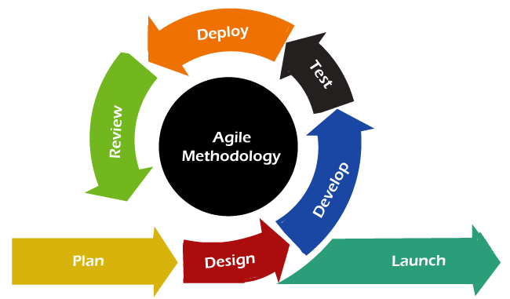After evaluating various development methodologies, Agile methodology is chosen for the development of the online hypermarket for student sellers. Agile’s flexibility, focus on customer feedback, and iterative approach make it well-suited for this project, where requirements may evolve, and user satisfaction is paramount.

Figure 1: Agile Methodology

##### 3.3.1 ADVANTAGES OF AGILE METHODOLOGY

* **Flexibility and Adaptability:** Agile allows for changes in requirements, ensuring the project can adapt to new insights and feedback from student sellers and consumers.
* **Customer Involvement:** Continuous feedback from end-users helps to refine the product, ensuring it meets their needs and expectations.
* **Frequent Delivery:** Regular sprints and iterations mean that functional software is delivered early and often, providing tangible progress.
* **Improved Quality:** Frequent testing and reviews within each iteration help to identify and fix issues promptly.
* **Enhanced Collaboration:** Agile fosters a collaborative environment where team members work closely together, improving communication and problem-solving.

##### 3.3.2 DISADVANTAGES OF AGILE METHODOLOGY

* **Uncertainty in Timelines and Budgets:** The iterative nature of Agile can make it challenging to predict the exact timelines and costs of the project.
* **Scope Creep:** Constant changes and additions to requirements can lead to scope creep if not managed carefully.
* **Requires Experience:** Agile requires a team with experience in Agile practices and a willingness to embrace its principles.

#### 3.4 SYSTEM DESIGN

System design involves creating a blueprint for the system’s architecture, data structures, and user interfaces. It translates the requirements identified during system analysis into technical specifications.

##### 3.4.1 SYSTEM ARCHITECTURE

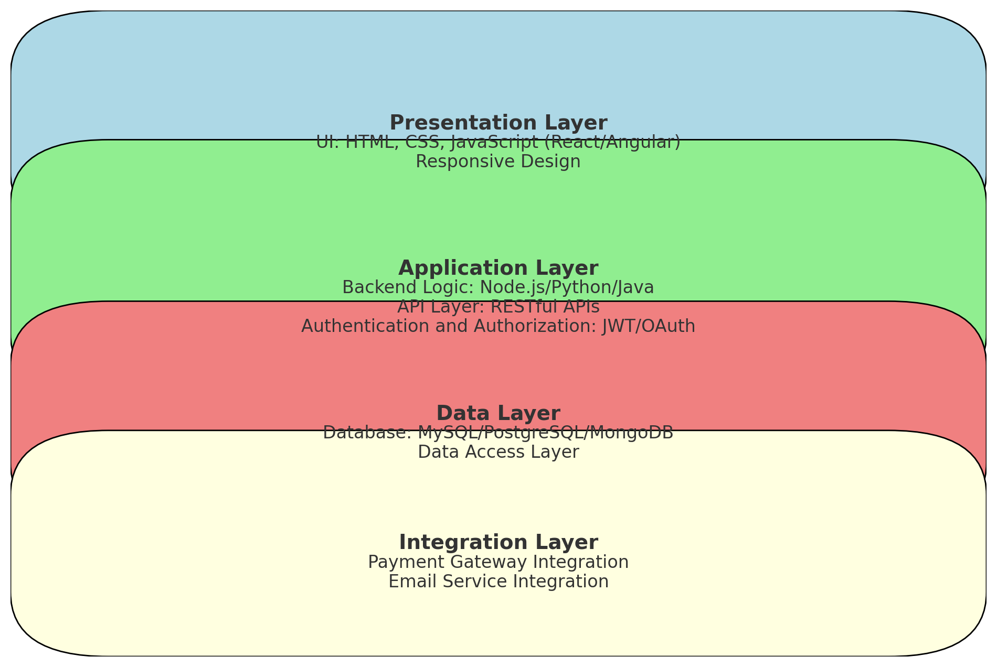The system architecture for the online hypermarket should follow a layered approach to ensure scalability, maintainability, and security. The key components include:

Figure 2 : System Architecture

1. **Presentation Layer:**
   * **User Interface (UI):** Web-based interface built with HTML, CSS, and JavaScript.
   * **Responsive Design:** Ensures accessibility across different devices (desktops, tablets, smartphones).
2. **Application Layer:**
   * **Backend Logic:** Implemented using PHP through the LARAVEL Framework
   * **API Layer:** RESTful APIs to facilitate communication between the frontend and backend.
   * **Authentication and Authorization:** Secure user authentication mechanisms using the Laravel AUTH package.
3. **Data Layer:**
   * **Database:** Relational databases to store user information, product details, and transaction records.
   * **Data Access Layer:** Ensures efficient and secure access to the database.
4. **Integration Layer:**
   * **Payment Gateway Integration:** Supports various payment methods (credit/debit cards, PayPal).
   * **Email Service Integration:** For sending notifications and confirmations.

##### 3.4.2 USER INTERFACE DESIGN

The UI design should focus on simplicity and ease of use, ensuring a positive user experience. Key design principles include:

1. **Consistent Layout:**
   * A consistent and intuitive layout helps users navigate the platform effortlessly.
2. **Responsive Design:**
   * Ensure the platform is accessible on various devices with different screen sizes.
3. **Clear Navigation:**
   * Use clear and concise navigation menus to help users find what they need quickly.
4. **Feedback Mechanisms:**
   * Provide users with feedback on their actions (e.g., confirmation messages, error messages).

#### 3.5 SYSTEM DESIGN MODELS

System design models provide a visual representation of the system architecture, processes, and data flows. These models include:

1. **Use Case Diagram:**
   * 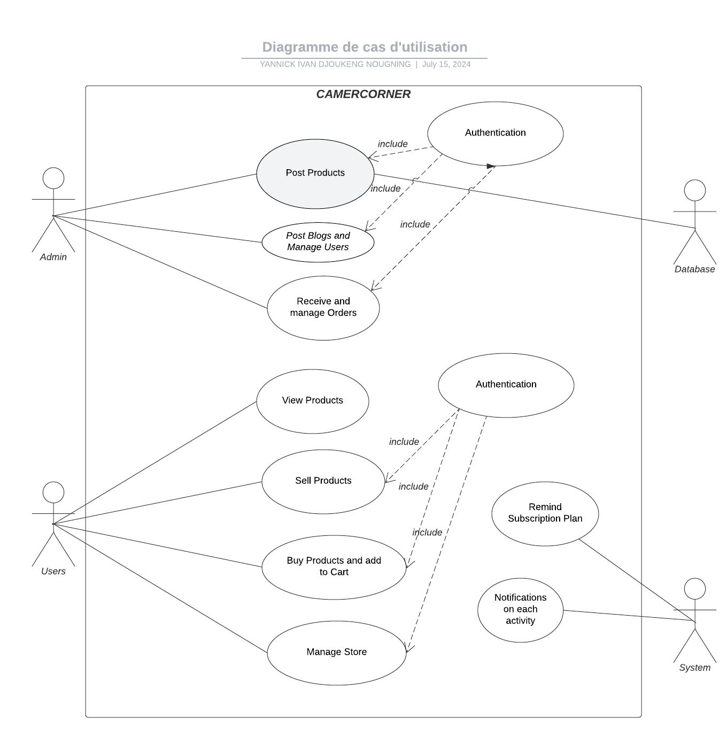Illustrate the interactions between users and the system for various functionalities.

Figure 3: Summary Use Case Diagram of the System

1. **Class Diagram:**
   * 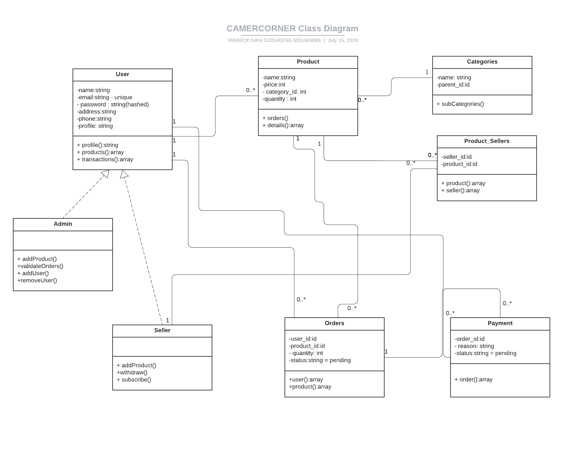Represent the static structure of the system, showing the system’s classes, their attributes, and relationships.

Figure 4: Summarized Class Diagram of CamerCorner

1. 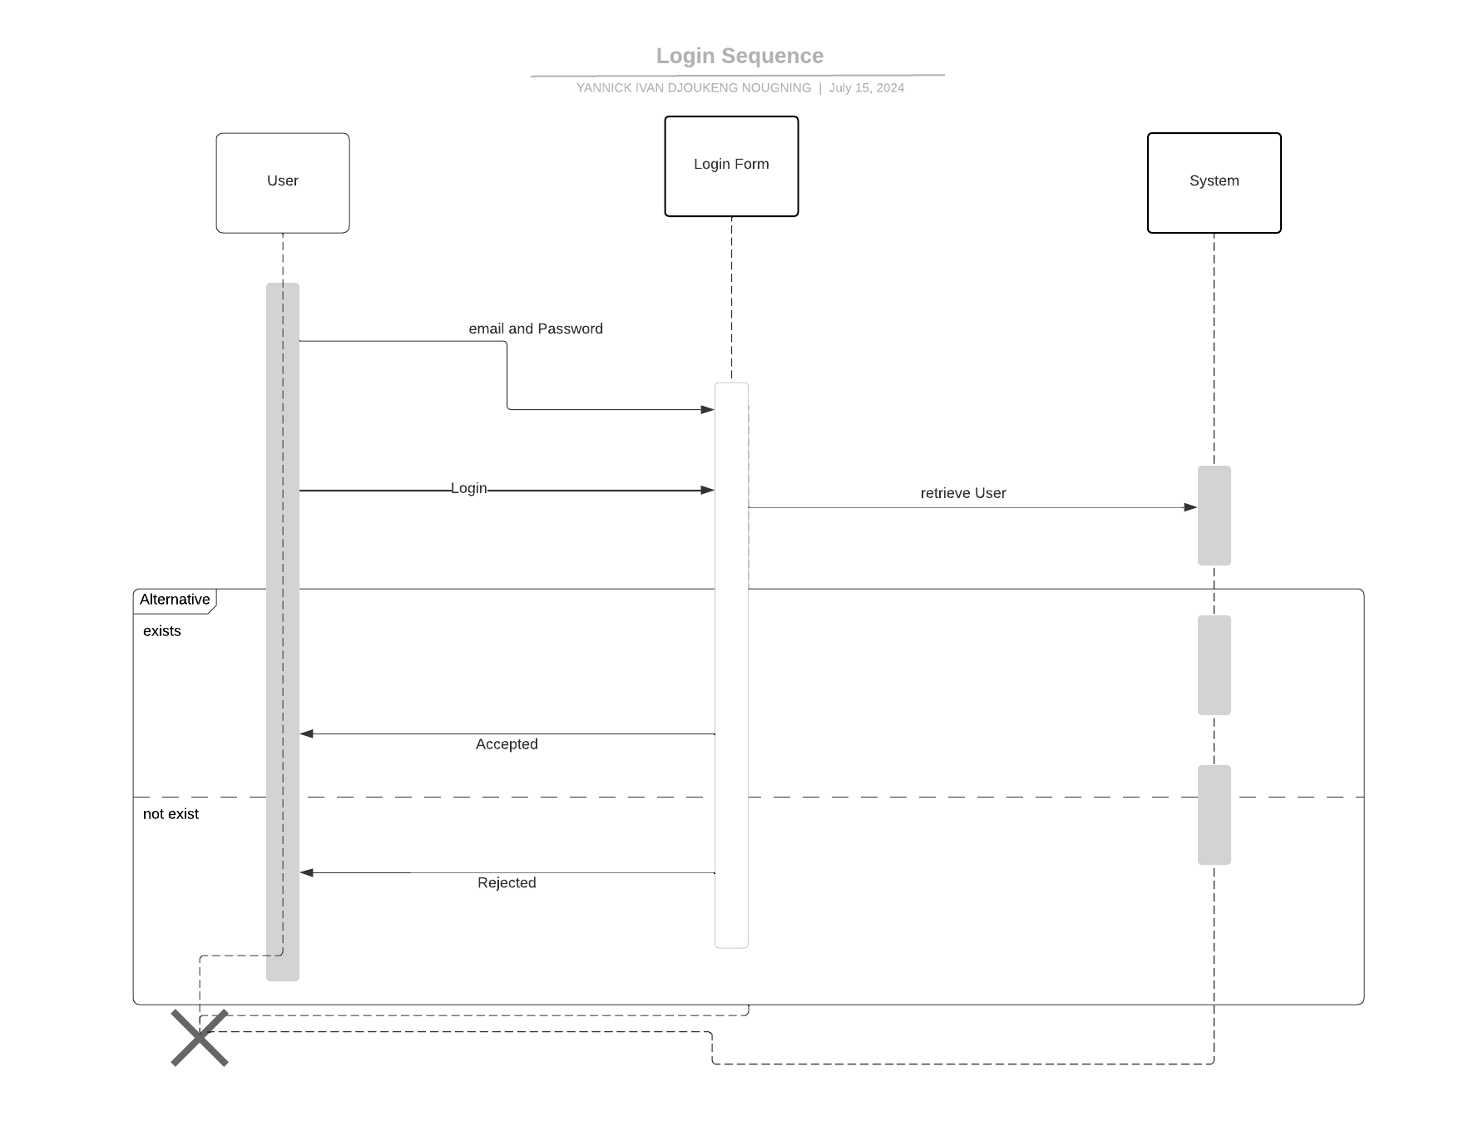**Sequence Diagrams:** Detail the interactions between objects in a particular use case, focusing on the order of messages exchanged.

Figure 5: Login Sequence Diagram

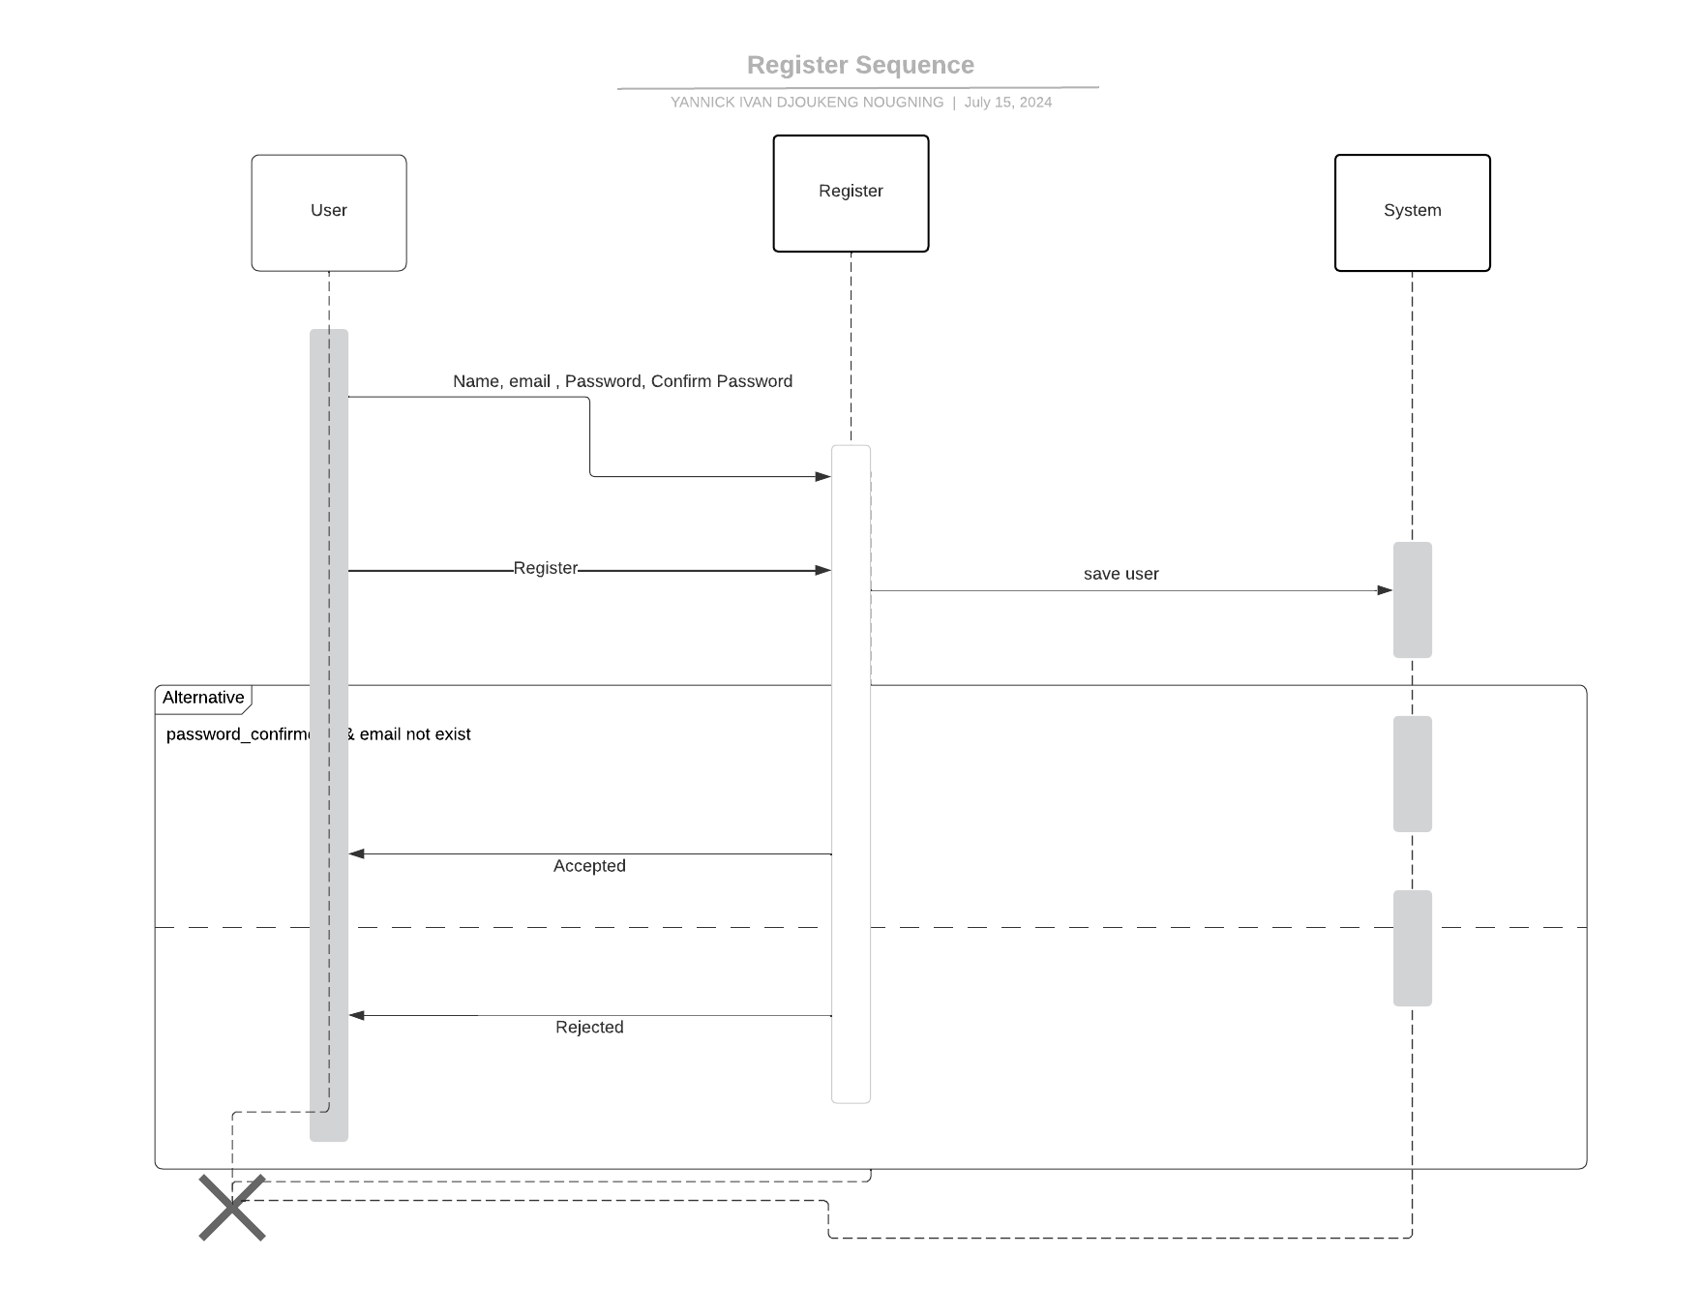

Figure 6: Registration Sequence Diagram

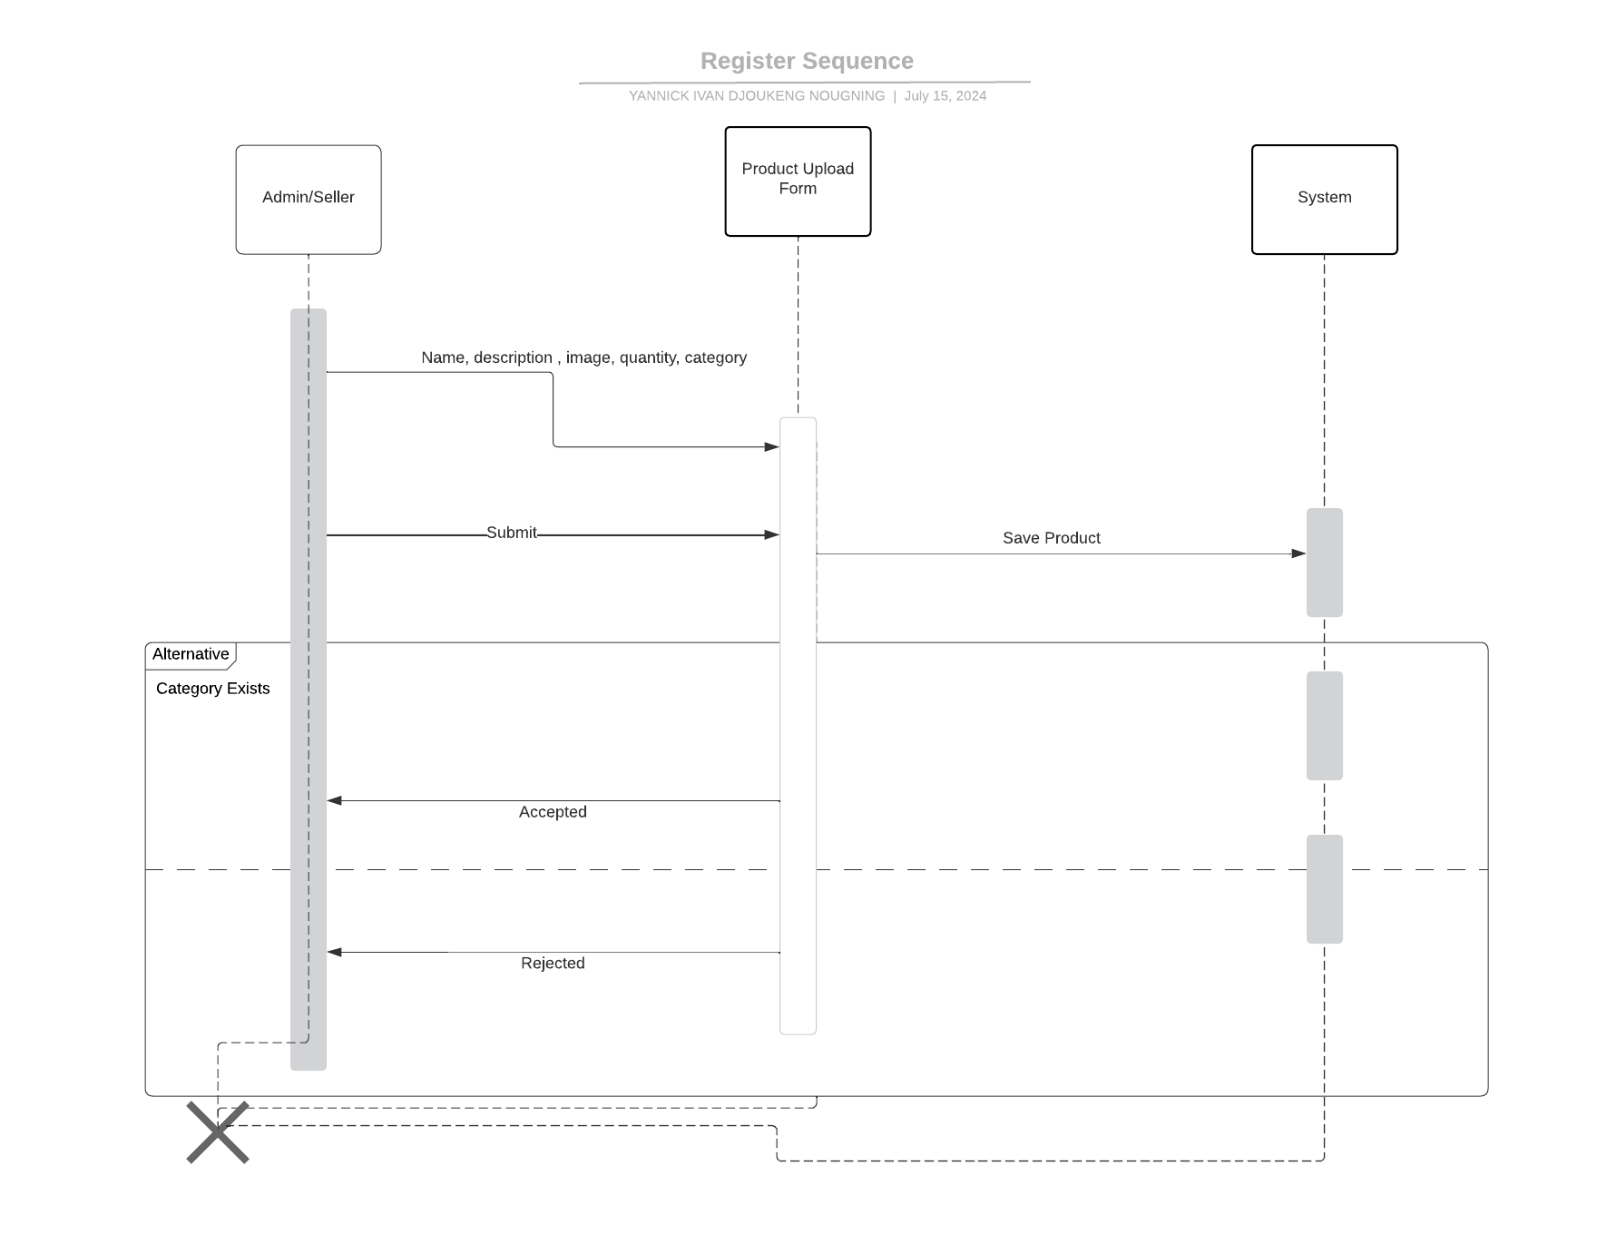

Figure 7: Product Upload Sequence Diagram

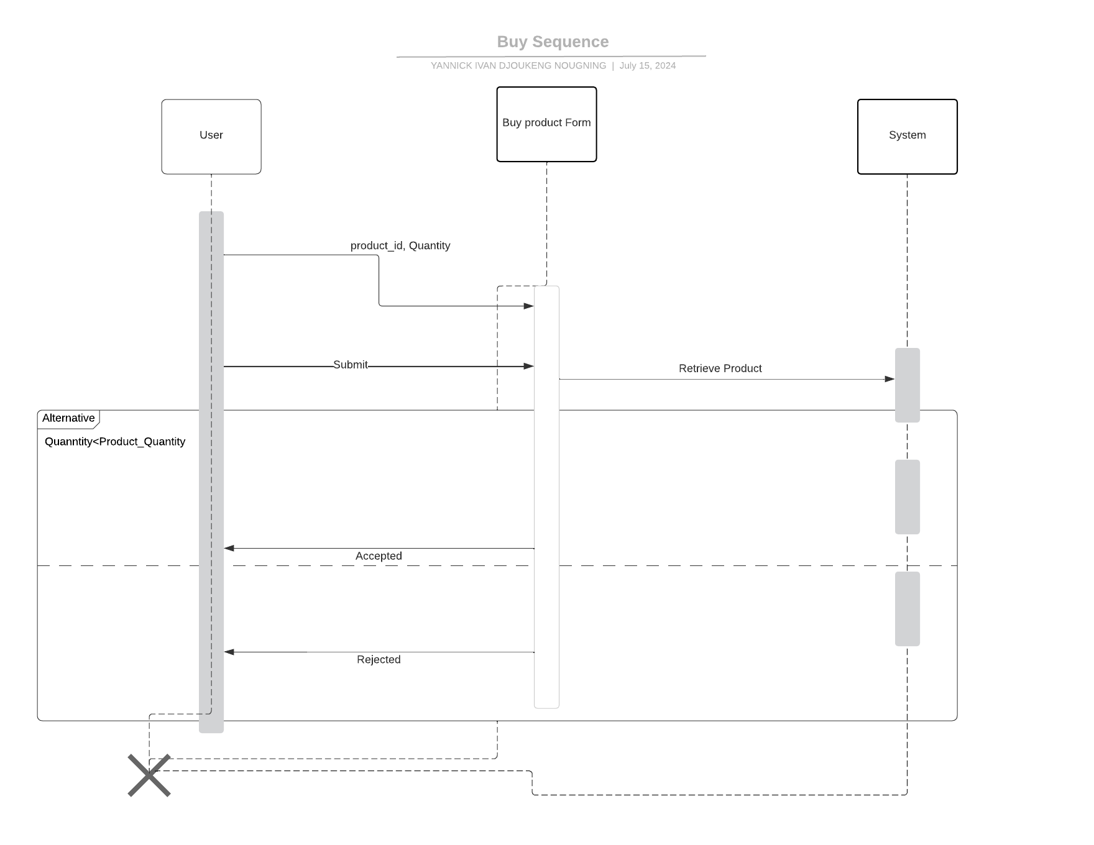

Figure 8: Buy Sequence Diagram

1. **Activity Diagrams:**
   * 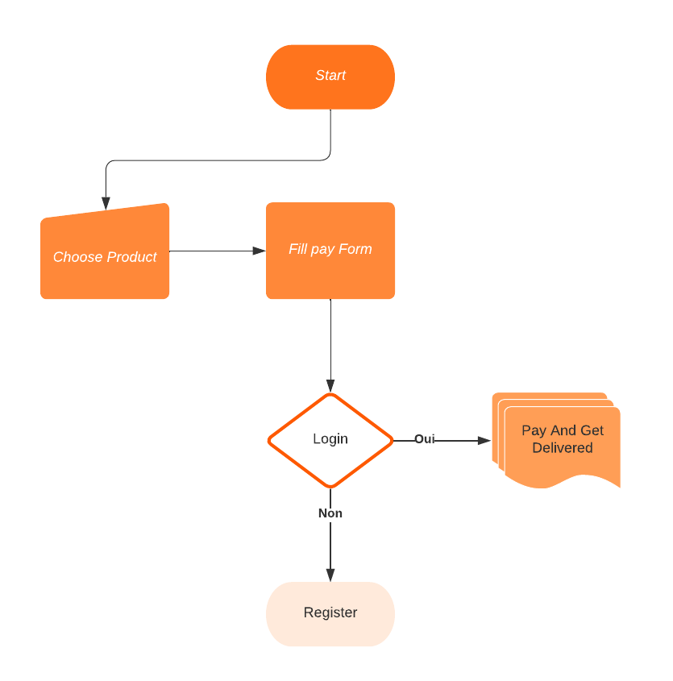Depict the dynamic aspects of the system, modeling the workflow of various processes.

Figure 9: Customer Purchasing good activity diagram

#### 3.6 SIMPLIFIED REVENUE MODEL

**Initial Capital:** 2,000,000 FCFA (Admin)

**Subscription Model:**

* Seller Subscription Fee: 1,000 FCFA per month

**Target Market:**

* University Population: 10,000

**Revenue Projections (Revised):**

* Focuses on monthly seller subscription growth (no transaction fee).
* Considers monthly recurring costs.
  + Hosting and Salaries: 300,000 FCFA / Year (25,000 FCFA/month)

**Calculations:**

1. **Monthly Seller Subscriber Growth:**
   * Conversion Rate * Target Population = New Sellers per Month
   * (e.g.) 5% * 10,000 = 500 potential sellers per month (hypothetical maximum)
   * We'll assume a more realistic **gradual enrollment**, considering 5% of the **unenrolled population** each month.
   * Month 1: 5% * (10,000 - 0) = 500 new sellers
   * Month 2: 5% * (10,000 - 500) = 475 new sellers (and so on)
2. **Cumulative Seller Subscribers:**
   * Maintain a table to track the growing number of sellers each month (start with Month 1: 500).
3. **Monthly Subscription Revenue:**
   * Cumulative Sellers * Subscription Fee = Monthly Subscription Revenue
   * (e.g.) Month 1: 500 sellers * 1,000 FCFA/seller = 500,000 FCFA
4. **Monthly Profitability:**
   * Monthly Subscription Revenue - Monthly Recurring Costs = Monthly Profit
   * We need the monthly subscription revenue to exceed the monthly recurring costs for profitability.

**Predicting Profitability:**

Due to the gradual enrollment, CamerCorner might take several months to become profitable. You'll need to create a table that tracks the cumulative sellers and monthly profits to determine the timeframe.

**Example (Hypothetical):**

|  |  |  |  |  |  |
| --- | --- | --- | --- | --- | --- |
| **Month** | **New Sellers** | **Cumulative Sellers** | **Monthly Revenue** | **Monthly Cost** | **Monthly Profit** |
| 1 | 500 | 500 | 500,000 | 25,000 | 475,000 |
| 2 | 475 | 975 | 975,000 | 25,000 | 950,000 |
| 3 | 451 (and so on) | ... | ... | 25,000 | ... |

**Important Notes:**

* This is a simplified model. A more comprehensive financial model would consider additional factors like marketing costs, potential churn rate (existing sellers leaving), and future cost adjustments.
* Continuously monitor and adjust your subscription fees and marketing strategies to optimize revenue growth and reach profitability faster.

#### 3.7 CONCLUSION

The analysis and design phase establishes a comprehensive framework for developing the online hypermarket for student sellers. By clearly defining the system requirements, architecture, database schema, user interface, and security measures, this chapter provides a solid foundation for the subsequent implementation and testing phases. The adoption of the Agile methodology ensures flexibility and continuous improvement, making it well-suited for this project. The next steps involve creating detailed UML diagrams to further refine the design and ensure all aspects of the system are well-documented and understood.

## CHAPTER FOUR: IMPLEMENTATION AND RESULTS

#### 4.1 INTRODUCTION

This chapter delves into the implementation process of the online hypermarket project, highlighting the utilized technologies, tools, and the achieved results. We'll explore how each element contributed to the project's success and discuss potential future enhancements.

#### 4.2 TOOLS AND TECHNOLOGIES USED

The project leveraged a powerful combination of technologies to bring the online hypermarket to life:

**Database Management System (DBMS):**

* **MySQL:** This widely used open-source relational database management system served as the backbone for storing product information, user data, orders, and other critical application data. MySQL's flexibility and scalability made it an ideal choice for managing the hypermarket's data needs.

**Development Tools:**

* **VS Code:** As the primary development environment, VS Code provided a versatile and customizable platform for writing clean and efficient code. With its extensive extensions for PHP development, VS Code streamlined workflows and enhanced developer productivity.

**Backend Development Framework:**

* **PHP Laravel:** This robust PHP framework offered a structured foundation for building the application's backend logic. Laravel features like:
  + **Eloquent ORM:** Enabled seamless interaction with the MySQL database through an object-relational mapper (ORM), simplifying data access and manipulation.
  + **Routing:** Efficiently managed incoming user requests and directed them to the appropriate application controllers.
  + **Authentication and Authorization:** Provided secure user login and account management functionalities, ensuring data integrity and access control.
  + **Built-in features:** Streamlined common development tasks like session management, form validation, and security measures.
* **XAMP/PhpMyAdmin:** It is a tool used to run and manage local php servers and applications

**Frontend Development Tools:**

* **Livewire:** This innovative Laravel library played a crucial role in creating dynamic and interactive user interfaces. Livewire components handled UI logic and interacted with the server efficiently, eliminating the need for full page reloads, resulting in a more responsive and engaging user experience.
* **JavaScrip**t: It is a scripting or programming language that enables you to create dynamically updating content, control multimedia, animate images, and pretty much everything else.
* **Tailwind CSS:** This utility-first CSS framework offered a low-level styling approach, allowing for rapid development and customization. Tailwind's extensive collection of pre-built classes provided a consistent and modern look and feel for the hypermarket's user interface.
* **HTML5/CSS3:** The fundamental building blocks of web development, HTML5 structured the content and semantics of the web pages, while CSS3 provided advanced styling capabilities for a visually appealing user interface.
* **Bootstrap 5 (Optional):** While not strictly necessary for this project, Bootstrap 5 could have been used as a pre-designed component library to jumpstart the development process.
* **Google Chrome:** It is a web browser that enables testing and inspecting of HTML/CSS coded pages

**Design and Collaboration:**

* **Lucidchart (Optional):** This online diagramming tool could have been valuable in the initial planning stages. By creating UML Diagrams in Lucidchart, developers could visually represent the relationships between different data entities (products, categories, users, orders) within the MySQL database, fostering better understanding and communication.

#### 4.3 DESCRIPTION OF THE IMPLEMENTATION PROCESS

The implementation process for the online hypermarket project involved several crucial stages, each contributing to the overall functionality of the platform. Here's a breakdown of each stage:

**1. Project Setup and Environment Configuration**

* **Install VS Code:** Download and install the latest version of VS Code as your primary code editor.
* **Install PHP Development Extensions:** Within VS Code, install essential extensions for PHP development, such as PHP Intellisense, Laravel Blade Snippets, and Laravel Artisan.
* **Laravel Project Setup:** Utilize the Laravel installer (laravel new your-project-name) to create a new Laravel project directory.
* **Database Configuration:** Configure the database connection details in the .env file. Specify the database host, username, password, and database name for your MySQL installation.
* **Application Configuration:** Review and adjust other application settings within the .env file as needed, such as application name, environment (local, development, production), and any custom configuration variables.

**2. Database Design and Migration**

* **Database Schema Definition:** There are two main approaches to define the database schema:
  + **Laravel Migrations:** This is the recommended approach. Create migration files using the php artisan make:migration create_products_table command. Each migration file defines the structure of a specific table (products, categories, users, etc.) using PHP code. This ensures version control and simplifies database schema changes.
  + **Direct MySQL Interaction:** Alternatively, you can use tools like phpMyAdmin or command-line MySQL tools to directly create tables within the MySQL database. However, this approach lacks the version control and ease of management offered by Laravel migrations.
* **Define Table Relationships:** Establish relationships between tables using foreign keys. For example, the orders table might have a foreign key referencing the user_id in the users table, linking a specific order to a particular user.

**3. Backend Development with Laravel**

* **Model Development:** Create Laravel models for each data entity using the php artisan make:model Product command. These models represent the structure of your database tables and provide methods to interact with the data through Laravel's Eloquent ORM.
* **Controller Implementation:** Develop Laravel controllers to handle user requests. Controllers receive incoming requests (e.g., browsing products, adding items to cart, processing checkout), perform necessary logic, and return responses (e.g., displaying product listings, updating cart totals, confirming order placement).
* **CRUD Operations:** Implement CRUD (Create, Read, Update, Delete) functionalities within controllers for product management. This involves:
  + **Create:** Allowing admins to add new products to the database.
  + **Read:** Retrieving product information from the database to display product listings, product details pages, or search results.
  + **Update:** Enabling admins to edit existing product information.
  + **Delete:** Providing the ability for admins to remove products from the database (with proper security measures in place).
* **Order Processing:** Develop functionalities for handling the order process. This includes:
  + Adding items to the shopping cart through controllers.
  + Managing cart contents (updating quantities, removing items).
  + Processing checkout logic, capturing user information and order details.
  + Interacting with the database to store order data.
* **Authentication and Authorization:** Implement user authentication and authorization features. Laravel provides built-in functionalities or allows integration with third-party packages to manage user logins, account creation, and access control. This ensures only authorized users can perform specific actions (e.g., only admins can manage products).

**4. Frontend Development with Livewire and Tailwind CSS**

* **Livewire Component Creation:** Develop Livewire components for various user interactions and functionalities. These components manage UI logic and communicate with the backend through Laravel controllers and models. Examples include:
  + **Product Listing Component:** Displaying a list of products with pagination, filtering, and sorting options.
  + **Product Details Component:** Presenting detailed information about a specific product, including images, descriptions, and prices.
  + **Shopping Cart Component:** Allowing users to view and manage their shopping cart contents, including adding, removing, and updating quantities of items.
  + **Checkout Process Components:** Guiding users through the checkout process, capturing user information, order details, and payment information (future integration).
  + **User Account Management Components:** Enabling users to manage their accounts, including profile information and order history (optional).
* **Tailwind CSS Integration:** Utilize Tailwind CSS classes to style the user interface components. Tailwind's utility-first approach offers a wide range of pre-built classes for layout, typography, responsiveness, and more, allowing for rapid and consistent UI development

#### 4.3 PRESENTATION OF RESULTS

* **LANDING PAGE**

This page is the first page a user sees before deciding to create or login to an account.

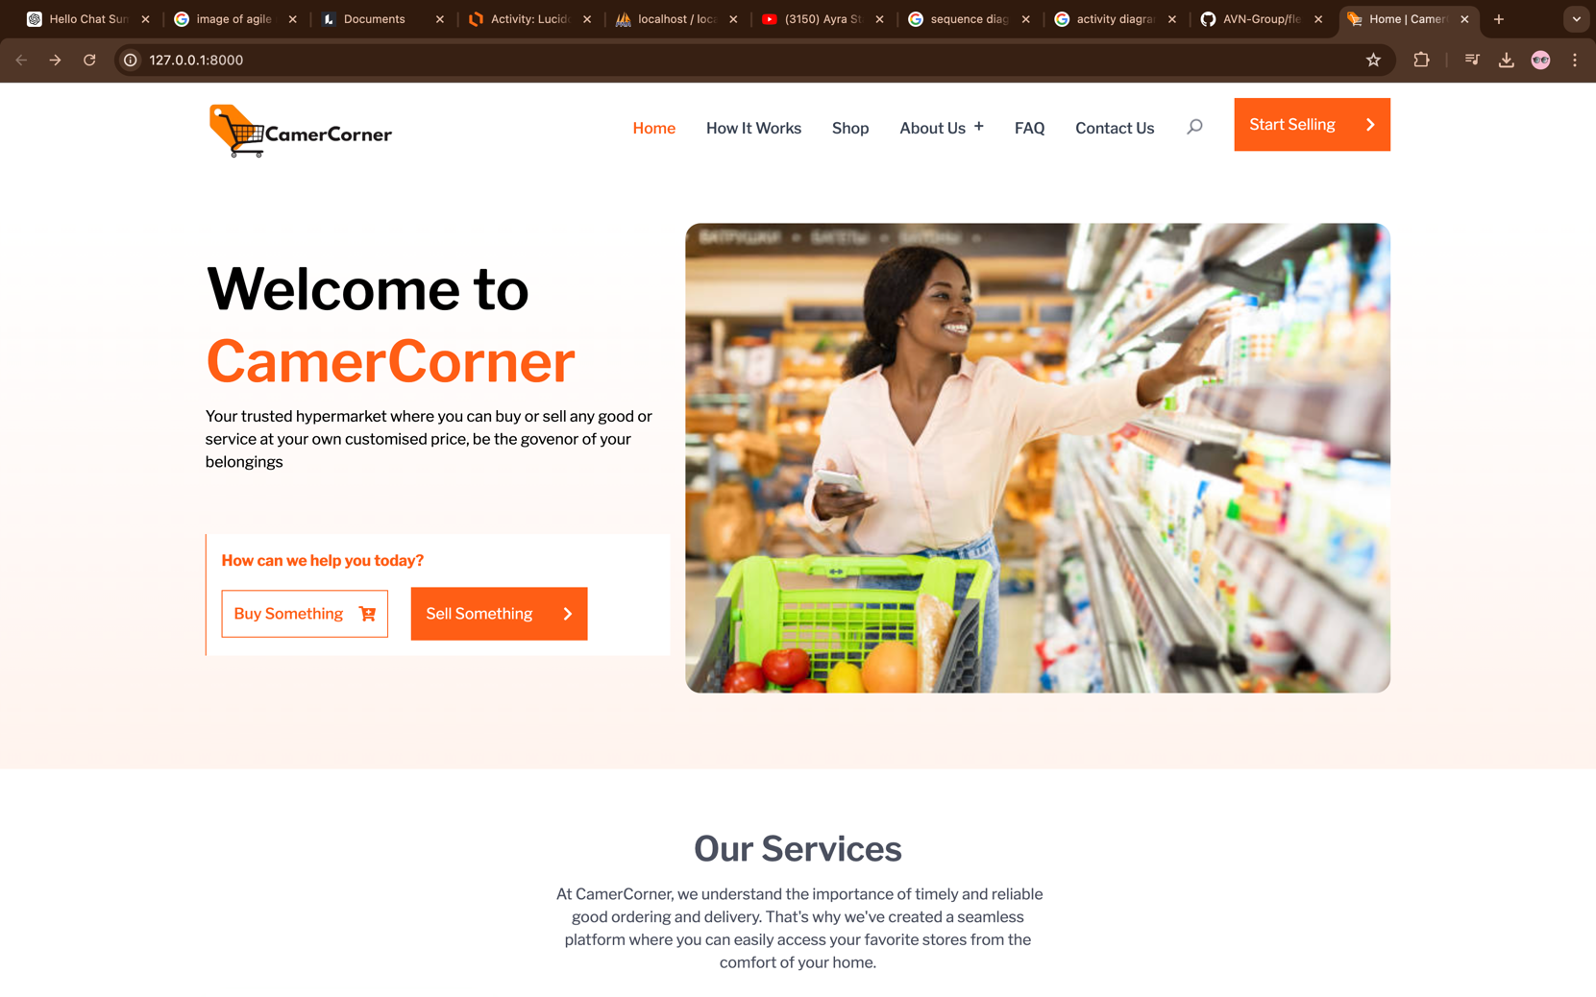

Figure 10: Landing page

* **SHOP PAGE**

In this page you have access to our platform’s products published by the student sellers with their shop names and prices

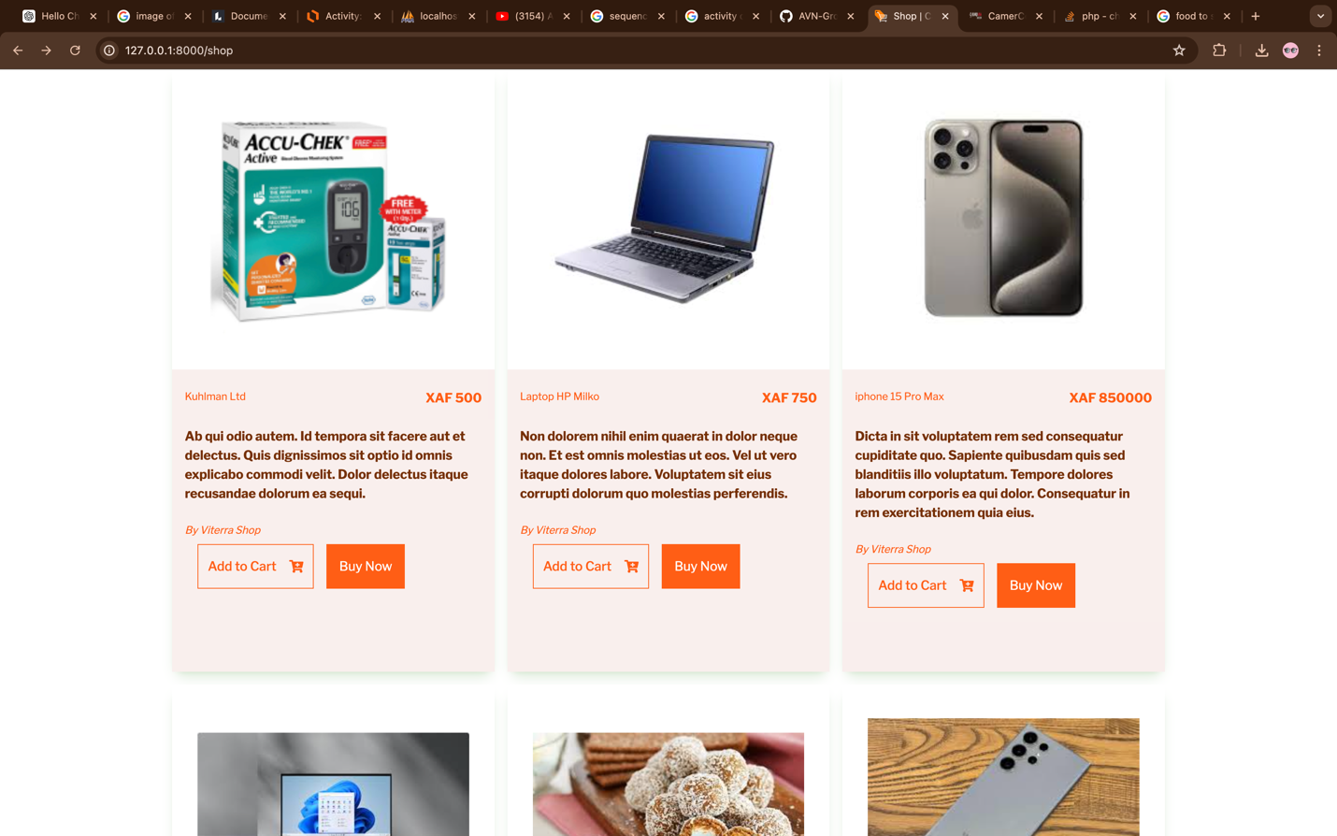

Figure 11: Shop Page

* **SHOP DETAIL PAGE**

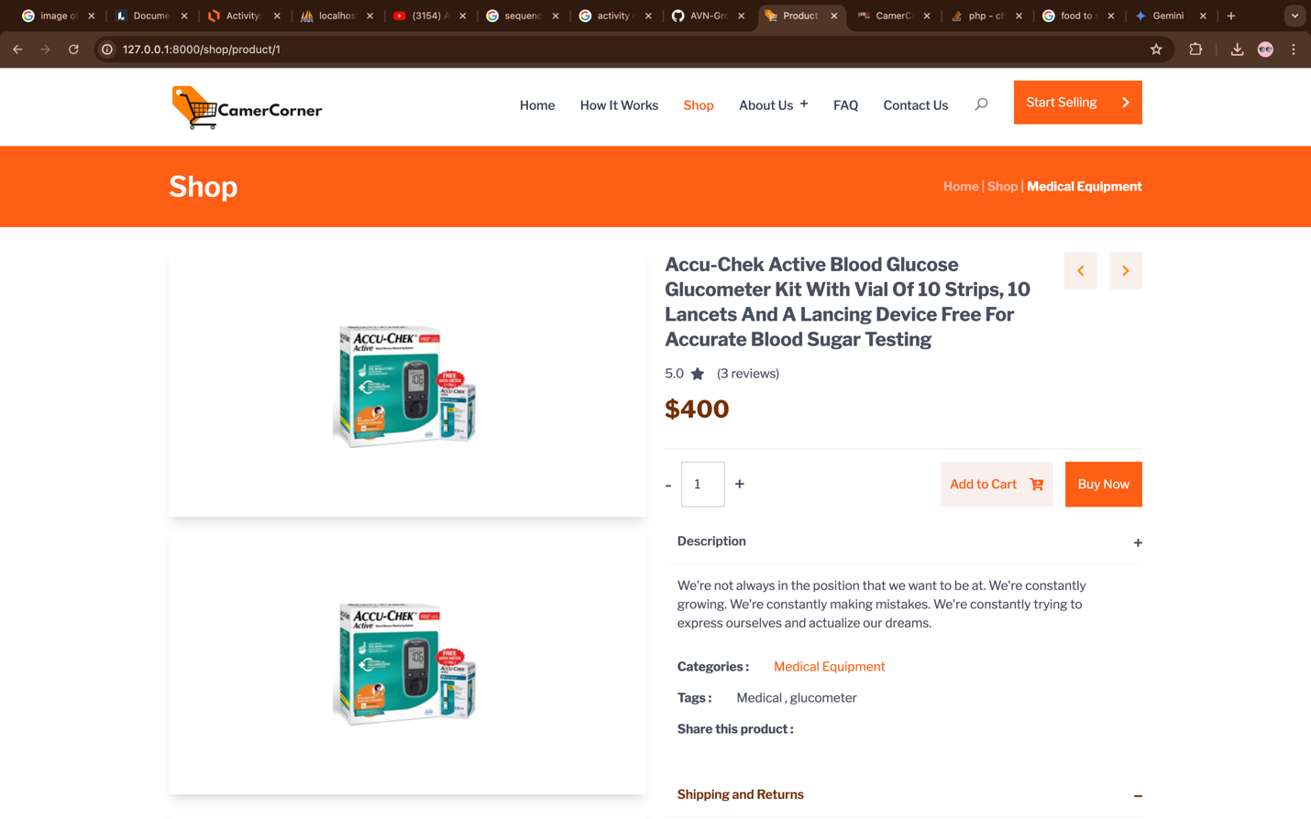Here we have the details of a product with the possibility of adding this product to cart or proceeding to buying directly

Figure 12:Shop Detail Page

* **USER CART**

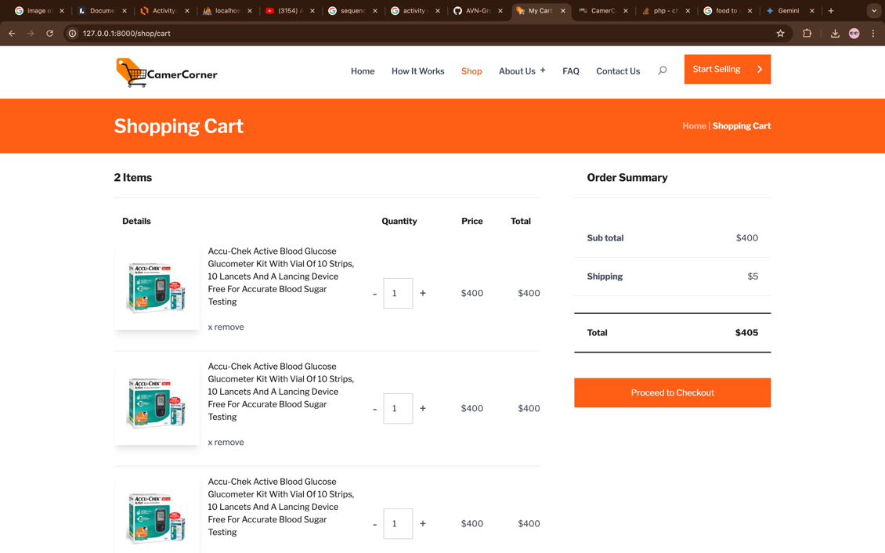The user can view products he added to cart

Figure 13: user product cart

* **CHECKOUT FORM**

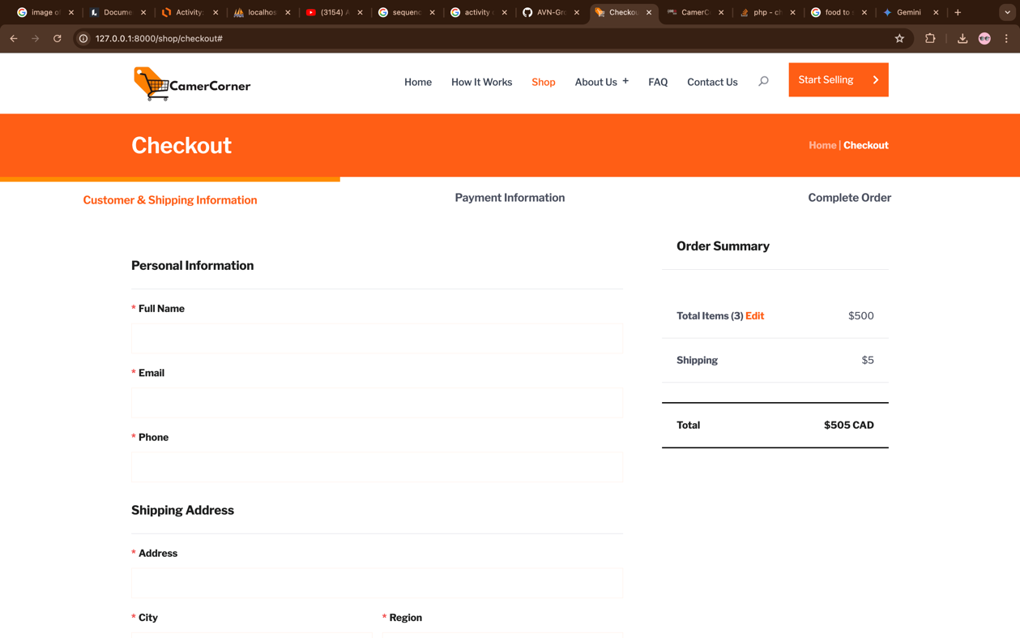Here is where a user will start the purchase of products that are in his cart

Figure 14: User Checkout

* **USER LOGIN PAGE**

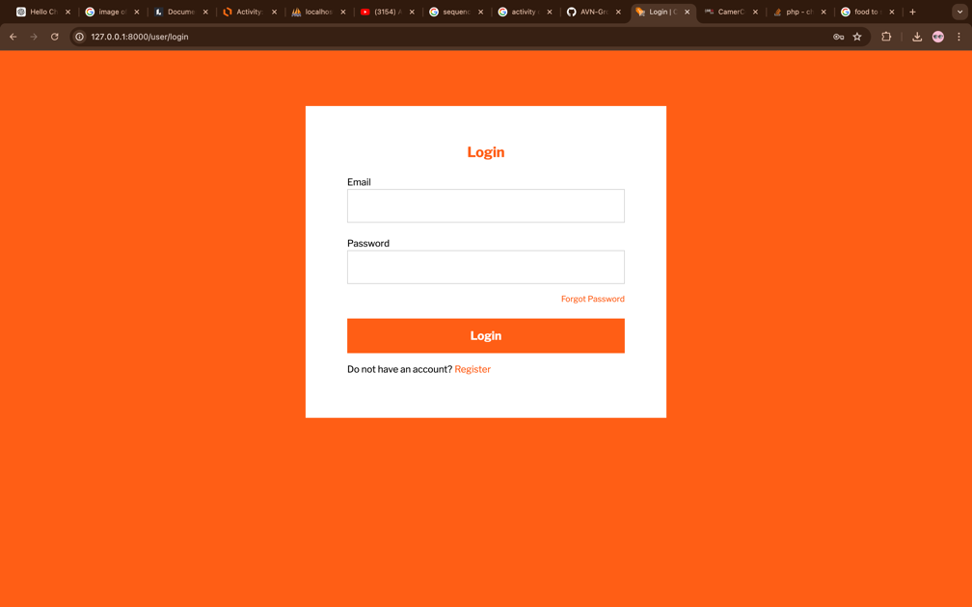This interface provides a form for the user to login to. Its only logged in users who can buy or sell on the platform

Figure 15: Login Page

* **USER DASHBOARD**

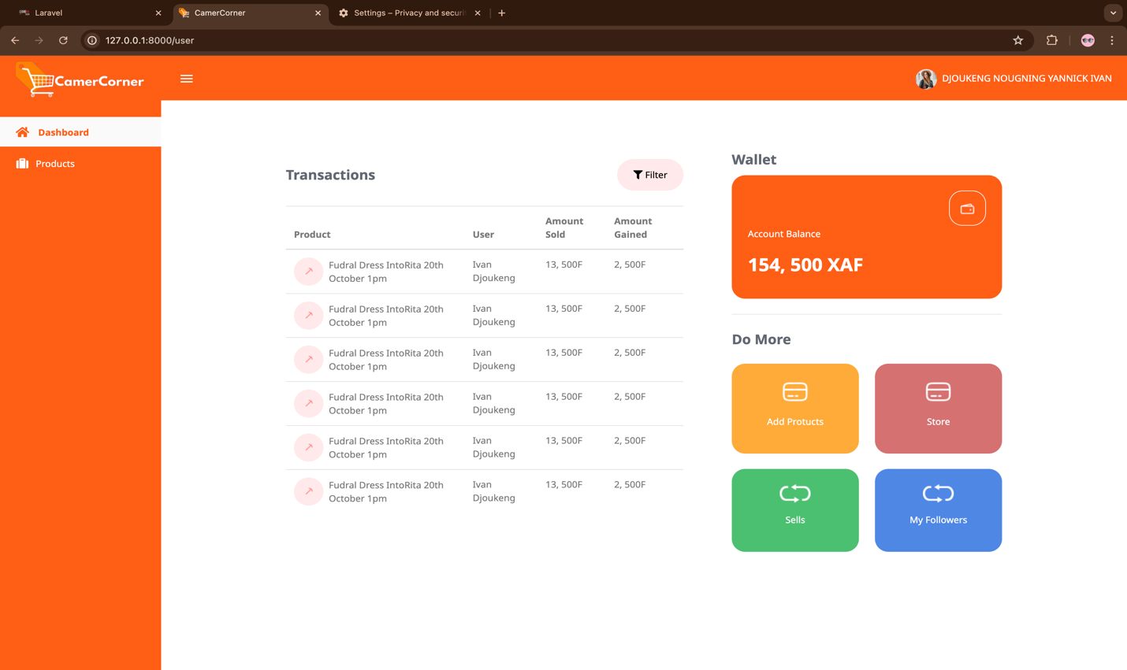Here is the dashboard where a user can manage his sells and his buying on the platform CamerCorner

Figure 16: User Dashboard

* **USER PRODUCTS**

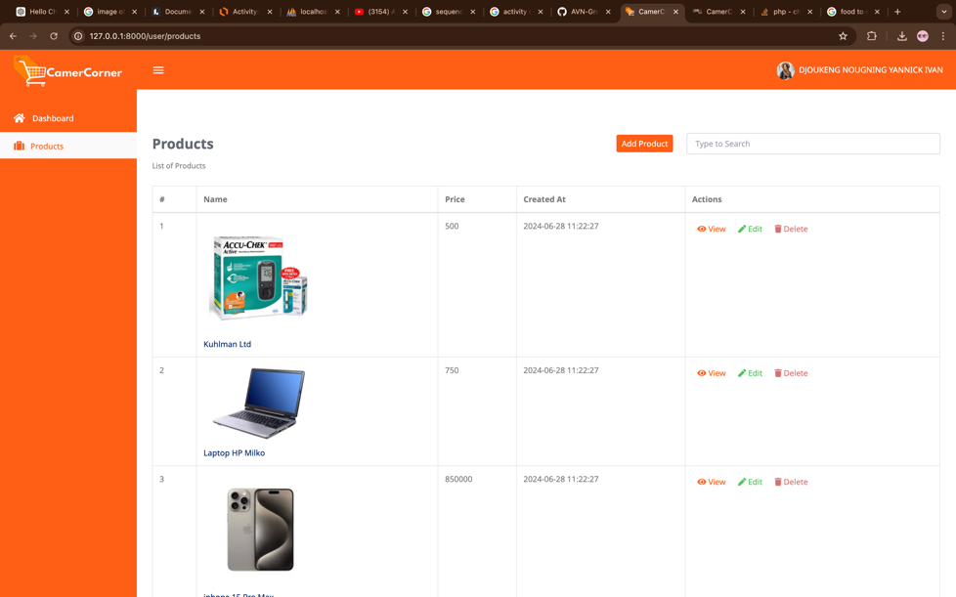In this interface you find the products a particular user published or chooses to sell.

Figure 17: User products

* **USER PRODUCT DETAILS**

In this interface a user find the details of a product he is selling and may even see the orders made on that product.

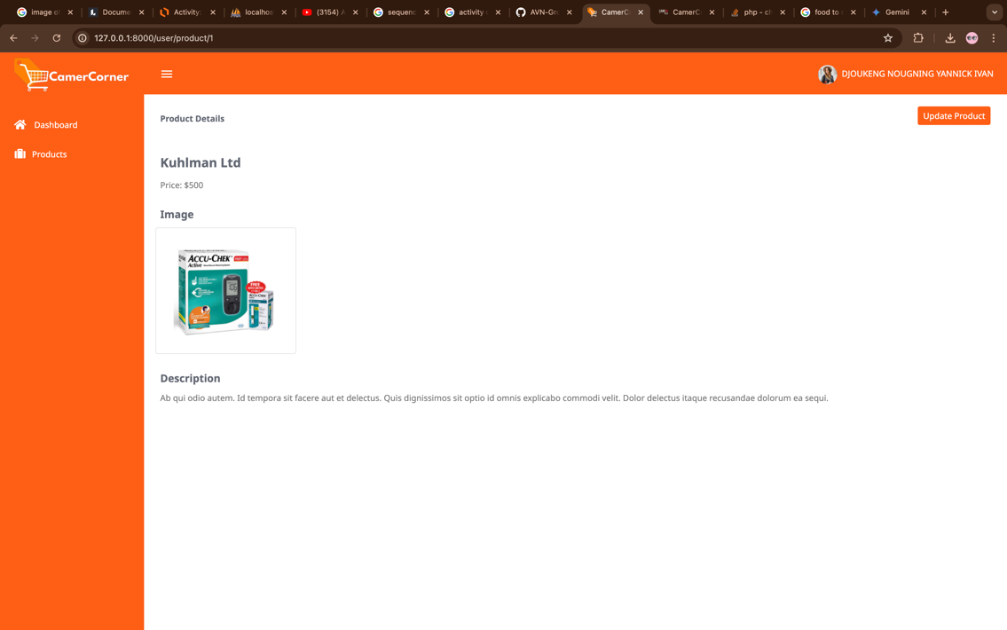

Figure 18: user product details

* **UPDATE PROFILE**

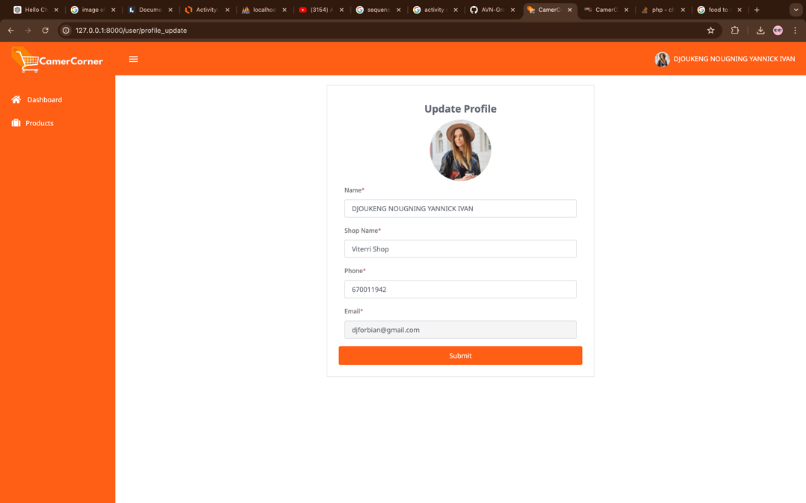In this interface, a user can update his/her profile and change its shop name

Figure 19: Update profile

* **ADMINISTRATOR DASHBOARD**

Here we have the administrator’s dashboard from where the admin manages the entire system. It has all the functional menus to add products, manage users and proceed delivaries



Figure 20: Admin dashboard

* **ADMINISTRATOR PRODUCT UPLOAD FORM**

This is the modal that the admin fills at the moment he wants to add a product to the system

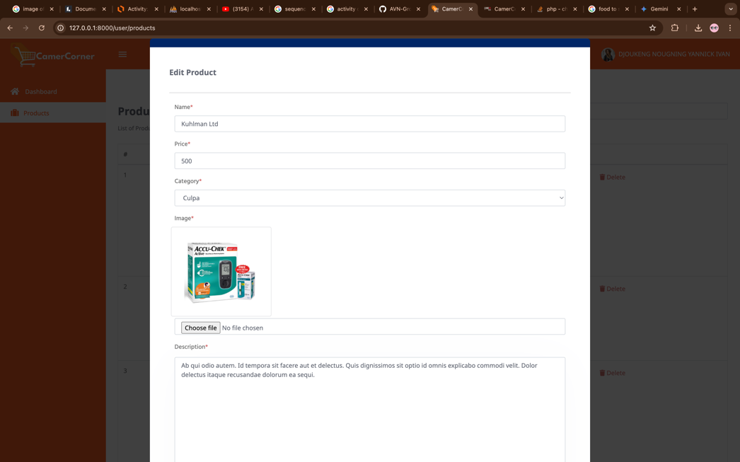

Figure 21: Administrator product upload

# CHAPTER FIVE: CONCLUSIONS AND FUTHER WORKS

## 5.1 SUMMARY OF THE WORK

This project has successfully brought to life the core functionalities of CamerCorner, a student-focused online hypermarket with dropshipping integration. Utilizing a robust technology stack with MySQL as the database backbone, Laravel for backend development, Livewire for interactive frontend elements, Tailwind CSS for stylish user interfaces, and potentially Lucidchart for initial planning, we have created a platform that empowers student sellers and fosters a dynamic online marketplace within the student community.

**Key Achievements:**

* **Empowering Student Sellers at CamerCorner:**
  + Developed a user-friendly platform for students to create seller accounts, upload product information, manage inventory, and track sales.
  + Implemented a secure system for student sellers to receive their earnings from product sales (future integration with payment gateway).
* **Dropshipping Integration at CamerCorner:**
  + Introduced a unique feature allowing students to participate in dropshipping. This low-risk entry point into e-commerce empowers students to sell products added by the admin (presumably wholesalers or distributors with pre-negotiated competitive rates) without needing upfront capital investment.
* **Responsive and User-Centric Design for CamerCorner:**
  + Leveraged responsive design principles to ensure CamerCorner adapts seamlessly to various devices (desktops, laptops, tablets, smartphones), offering a smooth user experience for all student sellers and buyers.
  + Focused on user-friendliness throughout CamerCorner, from intuitive product browsing and seller account management to a streamlined checkout process.

## 5.2 CONTRIBUTIONS TO ENGINEERING AND TECHNOLOGY

The CamerCorner project holds the potential to significantly impact the engineering and technology landscape within the University of Buea and Cameroon in general. Here's how:

**Empowering Student Entrepreneurs at the University of Buea:**

* **Platform for Student Businesses:** CamerCorner provides a dedicated platform for students at the University of Buea to showcase and sell their products. This fosters student entrepreneurship, allowing them to gain valuable business experience and generate income.
* **Reduced Barriers to Entry:** The dropshipping integration in CamerCorner eliminates the need for upfront capital, making it easier for students to venture into e-commerce and test their ideas.
* **Skill Development:** Students can gain valuable e-commerce and marketing skills through using CamerCorner as sellers. This prepares them for potential future careers in the digital economy.

**Boosting Innovation and Technology Adoption in Cameroon:**

* **E-commerce Adoption Model:** CamerCorner serves as a practical example of a successful e-commerce platform. This can inspire other universities in Cameroon and local businesses to explore e-commerce solutions, potentially leading to a wider adoption of these technologies and economic growth.
* **Showcasing Local Talent:** CamerCorner allows students to showcase their creativity and talent by selling unique, locally-made products. This can contribute to a thriving online marketplace showcasing Cameroonian innovation and entrepreneurship.
* **Building a Skilled Workforce:** The technologies used in CamerCorner (Laravel, Livewire, Tailwind CSS, MySQL) are in high demand. By studying the project's codebase, students within the University of Buea and across Cameroon can develop valuable skills, contributing to a more skilled workforce in these areas.

**Enhancing the University of Buea Community:**

* **Student Community Building:** CamerCorner fosters a sense of community among students by providing a platform for buying, selling, and interacting. This can contribute to a more vibrant and connected student environment at the University of Buea.
* **Entrepreneurial Support:** The platform can potentially become a hub for entrepreneurial support within the university. Workshops or training sessions on e-commerce or the underlying technologies can be hosted, equipping students with the knowledge to succeed in the digital marketplace.

**Expanding the Project's Reach:**

* **Open-Sourcing the Code:** Consider open-sourcing the code behind CamerCorner. This allows developers across Cameroon to learn from the project, potentially contribute to its further development, and potentially adapt it for use in other universities or local communities throughout the country.
* **Collaborations and Partnerships:** Partner with relevant university departments, business incubators, or e-commerce organizations within Cameroon. This can broaden the project's reach, attract additional resources, and create a network of support for student entrepreneurs.

By leveraging CamerCorner's potential and actively pursuing these opportunities, the project can play a vital role in fostering student entrepreneurship, promoting technology adoption, and enhancing the overall engineering and technology landscape within the University of Buea and Cameroon as a whole.

## 5.3 RECOMMENDATIONS

To successfully launch CamerCorner at the University of Buea, consider these recommendations for collaboration and support from the university and its faculties:

**University Administration:**

* **Project Recognition and Endorsement:** Seek official recognition and endorsement of CamerCorner by the university administration. This endorsement demonstrates support for student entrepreneurship and innovation, potentially attracting wider student participation and faculty involvement.
* **University Resources:** Explore the possibility of obtaining university resources, such as server space or technical support, to aid in hosting and maintaining the CamerCorner platform. This demonstrates the university's commitment to the project's success.
* **Marketing and Promotion:** Partner with the university's marketing department to promote CamerCorner through campus channels (website, social media, student publications) and events (entrepreneurship workshops, career fairs). This raises awareness and encourages student participation on both the seller and buyer sides.

**Faculties and Departments:**

* **Entrepreneurship Courses:** Integrate CamerCorner as a learning tool within relevant entrepreneurship or business courses offered by various faculties. Students can gain practical experience by using the platform to launch and manage their online stores.
* **Faculty Mentorship:** Encourage faculty members with expertise in e-commerce, marketing, or business management to provide mentorship and guidance to student sellers on CamerCorner. This can significantly contribute to the success of their student-run businesses.
* **Internship Opportunities:** Explore the possibility of creating internship opportunities within the CamerCorner project. This could involve students from computer science or business backgrounds assisting with platform maintenance, marketing initiatives, or data analysis.

**Additional Considerations:**

* **Student Government Collaboration:** Partner with the University of Buea's student government to promote CamerCorner among the student body. This leverages the reach and influence of student organizations to increase platform adoption.
* **Security and Regulations:** Develop clear policies and regulations governing the types of products allowed on CamerCorner, intellectual property rights, and user conduct. This ensures a secure and responsible online marketplace environment for all participants.
* **Sustainability Model:** Develop a sustainable model for CamerCorner's long-term operation. This could involve transaction fees, commission structures for student sellers, or potential partnerships with sponsors. The model needs to be fair and transparent for all stakeholders.

## 5.4 DIFFICULTIES ENCOUNTERED

Building CamerCorner, a student-focused online hypermarket with dropshipping integration, as a solo developer presented a unique set of challenges. Here's a retrospective on the difficulties I wrestled with during the analysis, design, and implementation phases:

**Analysis: Taming Feature Creep on My Own**

* **Balancing Ambition with Reality:** Without a team to brainstorm and refine ideas, I had a multitude of exciting features in mind for CamerCorner. The challenge was to rein myself in and define a realistic scope that balanced my ambition with the limitations of solo development. Prioritizing core functionalities and keeping the initial feature set manageable was crucial.

**Design: Balancing Wishes with Technical Realities**

* **Weighing User Dreams vs. Development Doability:** Understanding the needs of student sellers and buyers was essential. However, as the sole developer, I had to carefully assess those desires against the technical feasibility of implementing them. This likely involved making some tough calls, prioritizing essential functionalities within my skillset and timeframe.
* **Building a Secure Fortress:** Designing a secure platform for online transactions and user data protection often involves multiple perspectives. I had to conduct extensive research and leverage online resources to ensure robust security measures were built into the platform from the ground up. This solo effort ensured user trust and the safety of their data.

**Implementation: Integration Battles - A One-Person War**

* **Conquering the Tech Stack:** Learning and integrating Laravel, Livewire, Tailwind CSS, and MySQL as a single developer presented a significant challenge. I likely had to rely heavily on documentation, online tutorials, and potentially freelance support (if applicable) to overcome these integration hurdles. The learning curve for each technology, combined with the challenge of integrating them seamlessly, demanded a lot of dedication and resourcefulness.
* **Testing and Debugging: A Solo Quest:** Thorough testing of all functionalities is essential for a successful launch. As the sole developer, I had to dedicate significant time and effort to meticulously test every aspect of the platform and debug any errors encountered. This meticulous solo quest ensured a more robust and user-friendly platform at launch.

## 5.4 FUTHER WORKS

The successful development of CamerCorner lays a strong foundation for an even more robust and user-friendly platform. Here's a glimpse into some exciting possibilities for future work, incorporating Artificial Intelligence (AI) and advanced search functionalities:

**AI-Powered Product Recommendations:**

* **Leveraging User Data:** Integrate AI algorithms to analyze user purchase history, browsing behavior, and search queries. Based on this data, CamerCorner can recommend products to individual users, creating a more personalized shopping experience that caters to their specific interests and needs. This can lead to increased customer satisfaction and potentially boost sales for student sellers.
* **Real-Time Trend Analysis:** AI can analyze real-time sales data to identify trending products within specific categories. This information can be displayed prominently on the platform, allowing student sellers to capitalize on current market trends and student buyers to discover popular items.

**Advanced Search and Filter Functionalities:**

* **Faceted Search:** Implement a faceted search system that allows users to filter product results based on various criteria like category, price range, brand, size, color, and student seller (if applicable). This empowers buyers to refine their searches quickly and efficiently, leading to a more targeted product discovery process.
* **Natural Language Processing (NLP) Search:** Integrate NLP capabilities to enable users to search for products using natural language. Instead of just keywords, users could enter phrases like "red sneakers for running" or "affordable laptops for students" to find relevant products. This would make searching more intuitive and user-friendly for all.
* **AI-Powered Chatbots:** Develop AI-powered chatbots to assist both student sellers and student buyers. These chatbots can answer frequently asked questions, provide product recommendations, and guide users through the platform's functionalities. This can improve customer service, reduce support workload, and enhance the overall user experience.

**Additional Considerations:**

* **Data Security and Privacy:** As AI and user data become more prominent, ensure robust data security measures are in place to protect user privacy. Transparency regarding data collection and usage is crucial for maintaining user trust.
* **Scalability and Performance:** Consider the scalability of the platform as the user base grows. The infrastructure needs to be able to handle increasing traffic and data volumes while maintaining optimal performance.

## 

## REFERENCES

**Online References:**

* Firebear Studio: E-commerce Disrupting Supermarkets [Firebear Studio](https://firebearstudio.com/blog/the-ultimate-guide-to-the-future-of-e-commerce.html)
* Locus Blog: Supermarkets in E-commerce Age [Locus Blog](https://blog.locus.sh/grocery-is-now-everybodys-best-friend/)

**Books:**

* Multichannel Retailing by Barry Berman (2014)
* The Death of the Department Store by William C. Last (2019)

**Documentations:**

* Laravel Documentation: <https://laravel.com/docs/11.x/installation>
* Livewire Documentation: <https://laravel-livewire.com/docs/2.x/installation>
* Tailwind CSS Documentation: <https://tailwindcss.com/docs/installation>
* MySQL Documentation: <https://dev.mysql.com/doc/>